UNIT-I: Introduction to Machine Learning: Evolution of Machine Learning, Paradigms for ML, Learning by Rate, Learning by Induction, Reinforcement Learning, Types of Data, Matching, Stages in Machine Learning, Data Acquisition, Feature Engineering, Data Representation, Model Selection, Model Learning, Model Evaluation, Model Prediction, Search and Learning, Data Sets.

Machine Learning is a subfield of artificial intelligence (computer science) that enables algorithms to learn from data or observations and make predictions or clusters for unseen data point without explicit programming.
Evolution of Machine Learning:

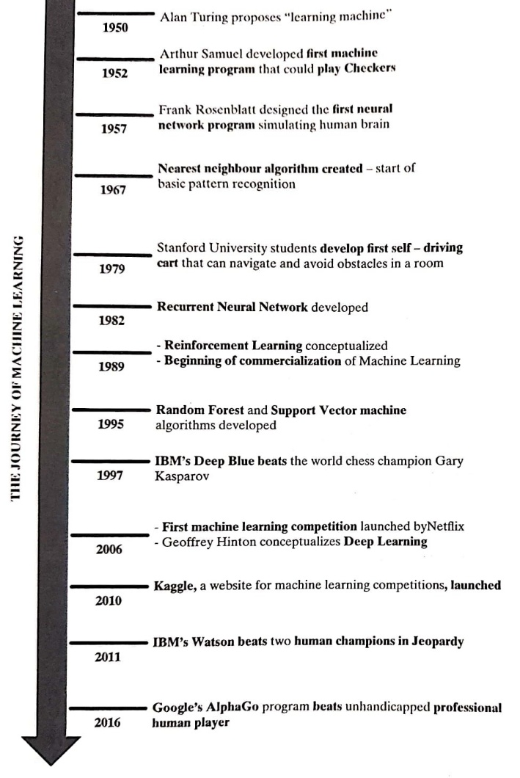

In machine learning, learning by rate and learning by induction are two different paradigms used to understand how algorithms process and acquire knowledge. Here's a breakdown of each:
Learning by Rate
Also known as learning by rate or memorization, this approach involves the system memorizing training data without attempting to generalize.
Learning by Induction
Learning by induction involves discovering patterns, relationships, or rules in data to generalize beyond the training set, k-NN(k=1) algorithm is an example of this approach.
The algorithm tries to create a model or hypothesis that generalizes from the training data to unseen instances.
Common techniques include decision trees, support vector machines, and neural networks.
Comparison
Feature | Learning by Rate | Learning by Induction
Definition | Memorization of exact data. | Deriving general rules from data.
Generalization | None; relies on specific examples. | High; aims to predict unseen data.
Memory Usage | High; stores all training data. | Moderate; stores a compressed model.
Robustness | Fails on unseen data. | Better suited for unseen data.
Examples | k-NN (k=1), lookup tables. | Decision trees, neural networks.
Reinforcement Learning (RL): Reinforcement Learning is a feedback-based Machine learning technique in which an agent learns to behave in an environment by performing the actions and seeing the results of actions. For each good action, the agent gets positive feedback, and for each bad action, the agent gets negative feedback or penalty.
In Reinforcement Learning, the agent learns automatically using feedbacks without any labeled data, unlike supervised learning. Since there is no labeled data, so the agent is bound to learn by its experience only. It solves a specific type of problem where decision making is sequential, and the goal is long-term, such as game-playing, robotics, etc.

Data in machine learning is a set of observations or measurement that are used to train, validate and test a machine learning model. Data is very crucial in machine learning because it is the foundation of creating accurate machine learning mode
Types of Data:
The data used in machine learning can be broadly categorized into two types −
- Numerical (quantitative) data
- Categorical (qualitative) data

Numerical (Quantitative) Data
The numerical (quantitative) data is data that can be measured, counted or given a numerical value. The examples of numerical data are age, height, income, number of students in class, number of books in a shelf, shoe size, etc.
The numerical data can be categorized into the folloiwng two types −
- Discrete Data
- Continuous Data
1. Discrete Data:
The discrete data is numerical data that is countable, finite, and can only take certain values, usually whole numbers. Examples of discrete data are number of students in class, number of books in a shelf, shoe size, number of ducks in a pond, etc.
2. Continuous Data:
The continuous data is numerical data that can take any value within a specified range including fractions and decimals. Examples of continuous data are age, height, weight, income, time, temperature, etc.
We can categorize the numerical data into the following two types on basis of true zero −
interval data − quantitative data with equal intervals between data points. Examples are temperature (Fahrenheit), temperature (Celsius), pH, SAT score (200-800), credit score (300-850), etc.
ratio data − same as interval data but with true zero. Examples are weight in KG, number of students, income, speed, etc.
Categorical (Qualitative) Data:
The categorical (qualitative) data can be categorized with or without a meaningful order. For example, gender, blood group, hair color, nationality, the school grades, level of education, range of income, ratings, etc.
The categorical data can be divided into the folloiwng two types −

- Nominal Data
- Ordinal Data
1. Nominal Data
The nominal data is categorical data that can not be arranged in an order or rank. The examples of nominal data are gender, blood group, hair color, nationality, etc.
2. Ordinal Data
The ordinal data is categorical data can be ordered or ranked with a specific attribute. The examples of ordinal data are the school grades, level of education, range of income, ratings, etc.
True Zero − it represents the absence of quantity being measured. The following table highlights how the four level of measurement are associated with the above discussed four features.
 | Nominal | Ordinal | Interval | Ratio
Categories | Yes | Yes | Yes | Yes
Rank Order |  | Yes | Yes | Yes
Equal Difference |  |  | Yes | Yes
True Zero |  |  |  | Yes
The nominal data is categorical data with no meaningful order whereas ordinal data is a categorical data with meaningful order. The concept of true zero plays role to differentiate interval and ratio data. Ratio data is same as interval data but it includes true zero.
Stages of Machine Learning are:
1. Problem Definition 2 Data Collection 3 Data Preparation 4 Data Visualization 5 ML Modelling
6 Feature Engineering 7 Model Deployment
Problem Definition
The first stage in the DDS Machine Learning Framework is to define and understand the problem that someone is going to solve. Start by analyzing the goals and the why behind a particular problem statement. Understand the power of data and how one can use it to make a change and drive results. And asking the right questions is always a great start.


Data Collection : Once the goal is clearly defined, one has to start getting the data that is needed from various available data sources.
Data Preparation can take up to 70% and sometimes even 90% of the overall project time.In Data Preparation one explores, pre-processes, conditions, and transforms data prior to modeling and analysis. It is absolutely essential to understand the data, learn about it, and become familiar before moving on to the next stage.


Data Visualization:
Data Visualization is used to perform Exploratory Data Analysis (EDA). When one is dealing with large volumes of data, building graphs is the best way to explore and communicate findings.
Some common ways of visualization:
Area Chart , Bar Chart, Box-and-whisker Plots, Bubble Cloud, Dot Distribution Map,
Heat Map Histogram.

ML Modeling
In this stage of the process one has to apply mathematical, computer science, and business knowledge to train a Machine Learning algorithm that will make predictions based on the provided data.
Feature Engineering
Feature Engineering is a process to achieve a set of features by performing mathematical, statistical, and heuristic procedures. It is a collection of methods for identifying an optimal set of inputs to the Machine Learning algorithm.

Model Deployment
The last stage is about putting a Machine Learning model into a production environment to make data-driven decisions in a more automated way.
Data Acquisition: The process of collecting and storing data for machine learning from a variety of sources is known as data acquisition (DAQ).

In machine learning, "data acquisition" refers to the procedure of obtaining and compiling data from diverse sources in order to test and train machine learning models.
The process of acquiring data also include taking the variable into account that affect its quality and utility, such as volume, velocity, and diversity.
A Data Acquisition (DAQ) system is capable of measuring several physical parameters, such as:
- Temperature: Temperature can be measured using RTDs, thermistors, or thermocouples in DAQ systems.
- Pressure: In a variety of settings, including industrial operations and medical equipment, pressure is measured using pressure sensors.
- Voltage: Power systems, electronics, and electrical engineering all depend on the ability of DAQ devices to monitor the voltage levels in electrical circuits.
- Current: DAQ systems can measure current flow using current sensors or shunts. Current measurement is essential in electrical systems.
- Strain and Pressure: Deformation and pressure in materials are measured using strain gauges and pressure sensors, which is crucial for material science and structural health monitoring.
- Shock and Vibration: In a variety of fields, including mechanical, aeronautical, and civil engineering, accelerometers and vibration sensors are used to monitor shock, vibration, and acceleration.
- RPM, Angle, and Discrete Events: DAQ systems are crucial for robotics, automation, and mechanical systems because they can measure rotational speed, angle, and discrete events.
- Distance and Displacement: Ultrasonic, laser, and encoder sensors are among the sensors that DAQ systems can use to detect distance and displacement.
- Weight: Measuring weight is crucial for a number of applications, including quality control, logistics, and industrial automation.
Feature Engineering:
Feature engineering is the process of translating a dataset into features such that these are able to represent the dataset more effectively for better performance in learning process .
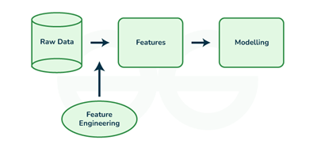
Fig. Feature Engineering

In the context of machine learning, a feature (also known as a variable or attribute) is an individual measurable property or characteristic of a data point that is used as input for a machine learning algorithm. Features can be numerical, categorical, or text-based, and they represent different aspects of the data that are relevant to the problem at hand.
For example, in a dataset of housing prices, features could include the number of bedrooms, the square footage, the location, and the age of the property. In a dataset of customer demographics, features could include age, gender, income level, and occupation.
Feature Transformation is the process of transforming the features into a more suitable representation for the machine learning model.
There are two variants of Feature Transformation: 1 Feature Construction 2. Feature extraction
Feature Construction: It is the process discovers missing information about the relationships between features and augments the feature space by creating additional features. If there are n features after feature creation ‘m’ more features may get added .The dataset will become ‘n+m’
dimensional
Feature extraction: It is the process of creating new features from existing ones to provide more relevant information to the machine learning model. This is done by transforming, combining, or aggregating existing features. This done by Principal Component Analysis (PCA) and Singular value Decomposition (SVD)
. 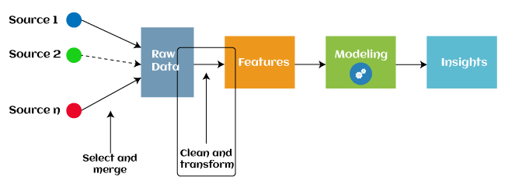

I Feature Transformation:
1. Feature Creation: Feature creation is finding the most useful variables to be used in a predictive model. The new features are created by mixing existing features using addition, subtraction, and ration, and these new features have great flexibility.
Encoding categorical variables and transforming numeric(continuous) features to categorical features: The transformation step of feature engineering involves adjusting the predictor variable to improve the accuracy and performance of the model. For example, it ensures that the model is flexible to take input of the variety of data; it ensures that all the variables are on the same scale, making the model easier to understand. It improves the model's accuracy.
2. Feature Extraction: Feature extraction is an automated feature engineering process that generates new variables by extracting them from the raw data. The main aim of this step is to reduce the volume of data so that it can be easily used and managed for data modelling. Feature extraction methods include cluster analysis, text analytics, edge detection algorithms, and principal components analysis (PCA).
II. Feature Selection(Feature Subset Selection): While developing the machine learning model, only a few variables in the dataset are useful for building the model, and the rest features are either redundant or irrelevant. If we input the dataset with all these redundant and irrelevant features, it may negatively impact and reduce the overall performance and accuracy of the model. Hence it is very important to identify and select the most appropriate features from the data and remove the irrelevant or less important features, which is done with the help of feature selection in machine learning. "Feature selection is a way of selecting the subset of the most relevant features from the original features set by removing the redundant, irrelevant, or noisy features."
Below are some benefits of using feature selection in machine learning:
i. It helps in avoiding the curse of dimensionality.
ii. It helps in the simplification of the model so that the researchers can easily interpret it.
iii. It reduces the training time.
iv. It reduces overfitting hence enhancing the generalization.
Data Representation:
The process of collecting the data and analyzing that data in large quantity is known as statistics
It refers to the process of condensing the collected data in a tabular form or graphically. This arrangement of data is known as Data Representation.

Types of Graphical Data Representation
Bar Chart
Bar chart helps us to represent the collected data visually. The collected data can be visualized horizontally or vertically in a bar chart like amounts and frequency. It can be grouped or single.
It helps us in comparing different items. By looking at all the bars, it is easy to say which types in a group of data influence the other.
Now let us understand bar chart by taking this example
Let the marks obtained by 5 students of class V in a class test, out of 10 according to their names, be: 7,8,4,9,6
The data in the given form is known as raw data. The above given data can be placed in the bar chart as shown below:
Name | Marks
Akshay | 7
Maya | 8
Dhanvi | 4
Jaslen | 9
Muskan | 6
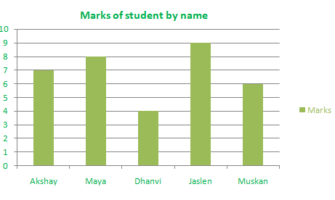
Histogram
A histogram is the graphical representation of data. It is similar to the appearance of a bar graph but there is a lot of difference between histogram and bar graph because a bar graph helps to measure the frequency of categorical data. A categorical data means it is based on two or more categories like gender, months, etc. Whereas histogram is used for quantitative data.

For example:
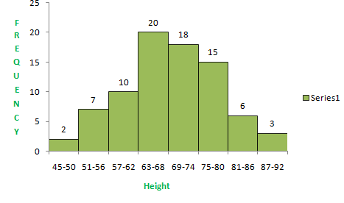
Line Graph
The graph which uses lines and points to present the change in time is known as a line graph. Line graphs can be based on the number of animals left on earth, the increasing population of the world day by day, or the increasing or decreasing the number of bitcoins day by day, etc. The line graphs tell us about the changes occurring across the world over time. In a line graph, we can tell about two or more types of changes occurring around the world.
For Example:
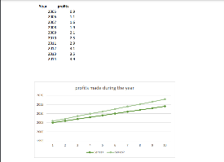
Pie Chart
Pie chart is a type of graph that involves a structural graphic representation of numerical proportion. It can be replaced in most cases by other plots like a bar chart, box plot, dot plot, etc. As per the research, it is shown that it is difficult to compare the different sections of a given pie chart, or if it is to compare data across different pie charts.

1 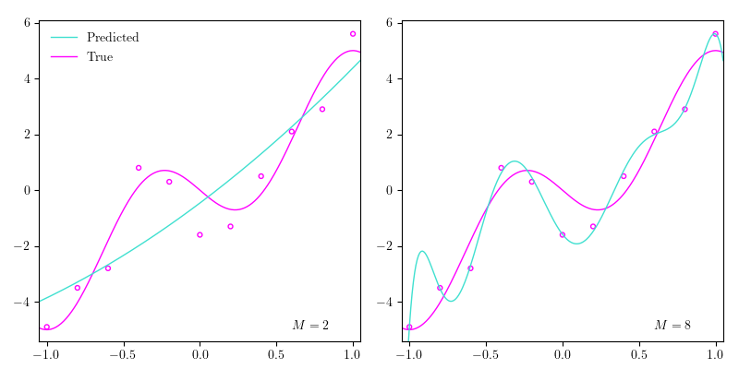
Fig. Illustration of underfitting (left) and overfitting (right).

Model Selection is the process of choosing the best model among all the potential candidate models for a given problem. The aim of the model selection process is to select a machine learning algorithm that evaluates to perform well against all the different parameters. It is as essential as any other technique for the model performance improvement, such as data pre-processing that involves cleaning, transforming, and scaling the data before training, feature engineering to transform features and create new ones, hyperparameter tuning to find the best combination of parameters to optimize the model performance and many more.
There are primarily five types of models in machine learning- Classification model, regression model, clustering model, dimensionality reduction model, and generative model
Classification Model: The classification model is used for predicting a categorical variable for a given data set. Logistic regression, decision trees, and neural networks are a few examples.
Regression Model: Such models perform the prediction of a continuous value for a given input. Examples of regression models include Linear regression, polynomial regression, and support vector regression predictive model.
Clustering Model: They comprise unsupervised learning algorithms that are used to group similar observed data points. K-means, Hierarchical Clustering, and DBSCAN are a few examples.

Dimensionality Reduction Model: These models are used to reduce the number of features in a dataset by some functional mapping. Examples of such statistical models are Principal Component Analysis (PCA), Linear Discriminant Analysis (LDA), and t-SNE.
Generative Model
They produce new data that is comparable to the training dataset. Generative Adversarial Networks (GANs), Variational Autoencoders (VAEs), and autoregressive models are some examples. These models are utilized in picture production, text generation, and anomaly detection applications.
Model Learning:
Hold-Out Method: The hold-out method for training the machine learning models is a technique that involves splitting the data into different sets: one set for training, and other sets for validation and testing. The hold-out method is used to check how well a machine learning model will perform on the new data. In this method 70-80% of data randomly selected as training data and remaining 20-30% data hold back as testing data. In some cases, the data can be divided into three parts as Testing, validation and Testing datasets.
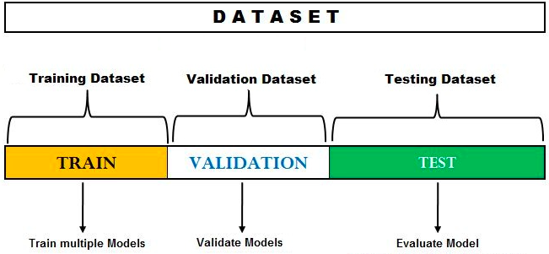
Fig. Hold out Method
K-Fold Cross Validation Method: K-fold cross-validation approach divides the input dataset into K groups of samples of equal sizes. These samples are called folds. For each learning set, the prediction function uses k-1 folds, and the rest of the folds are used for the test set. This approach is a very popular Cross Validation (CV) approach because it is easy to understand, and the output is less biased than other methods.
The steps for k-fold cross-validation are:
- Split the input dataset into K groups
- For each group:
  - Take one group as the reserve or test data set.
  - Use remaining groups as the training dataset

  - Fit the model on the training set and evaluate the performance of the model using the test set.
Let's take an example of 5-folds cross-validation. So, the dataset is grouped into 5 folds. On 1st iteration, the first fold is reserved for test the model, and rest are used to train the model. On 2nd iteration, the second fold is used to test the model, and rest are used to train the model. This process will continue until each fold is not used for the test fold.

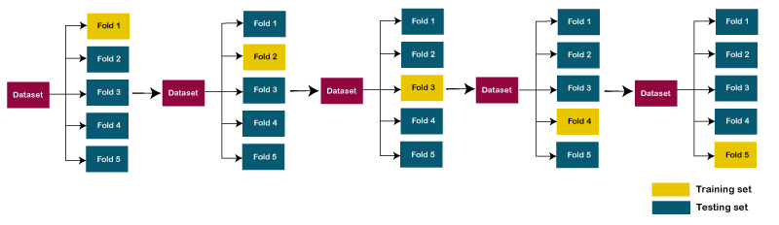
Leave one out cross-validation(LOOCV):
In this approach, for each learning set, only one datapoint is reserved, and the remaining dataset is used to train the model. This process repeats for each datapoint. Hence for n samples, we get n different training set and n test set. It has the following features:
- In this approach, the bias is minimum as all the data points are used.
- The process is executed for n times; hence execution time is high.
- This approach leads to high variation in testing the effectiveness of the model as we iteratively check against one data point.
Ensemble learning:
Ensemble learning combines multiple learners to improve predictive performance. It has been adopted in response to issues resulting from limited datasets.
Ensemble learning is a machine learning technique that aggregates two or more learners (e.g. regression models, neural networks) in order to produce better predictions. In other words, an ensemble model combines several individual models to produce more accurate predictions than a single model alone. Ensemble learning.

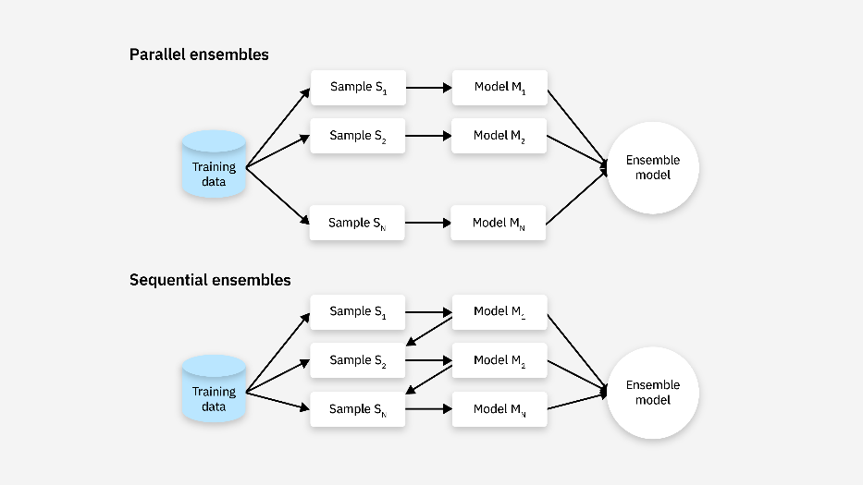
Fig. Ensemble Technique

Bagging: Bagging is a homogenous parallel method sometimes called bootstrap aggregating. It uses modified replicates of a given training data set to train multiple base learners with the same training algorithm.
Boot-Strap: More specifically, bagging uses a technique called bootstrap resampling to derive multiple new datasets from one initial training dataset in order to train multiple base learners. Let a training dataset contains n training examples. Bootstrap resampling copies n data instances from that set into a new subsample dataset, with some initial instances appearing more than once and others excluded entirely. These are bootstrap samples. Repeating this process x times produces x iterations of the original dataset, each containing n samples from the initial set. Each iteration of the initial set is then used to train a separate base learner with the same learning algorithm.
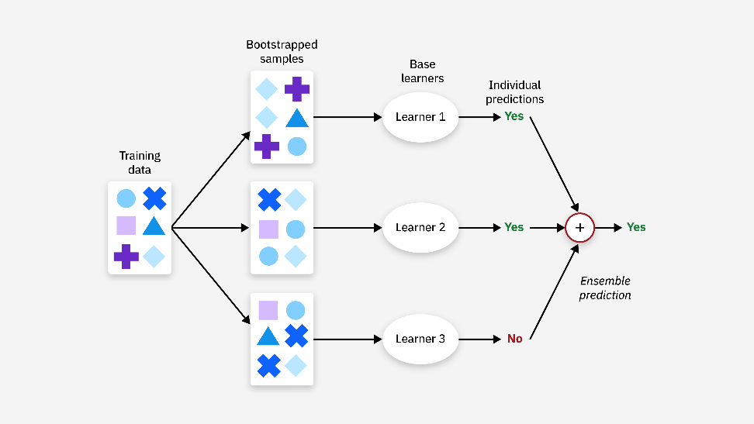
Fig. Bagging(Ensemble)
Fig.Boot-Strap

Boosting: Boosting algorithms are a sequential ensemble method. Boosting has many variations, but they all follow the same general procedure. Boosting trains a learner on some initial dataset, d. The resultant learner is typically weak, misclassifying many samples in the dataset. Much like bagging, boosting then samples instances from the initial dataset to create a new dataset (d2). Unlike bagging, however, boosting prioritizes misclassified data instances from the first model or learner. A new learner is trained on this new dataset d2. Then a third dataset (d3) is then compiled from d1 and d2, prioritizes the second learner’s misclassified samples and instances in which d1 and d2 disagree. The process repeats n times to produce n learners. Boosting then combines and weights the all the learners together to produce final predictions.
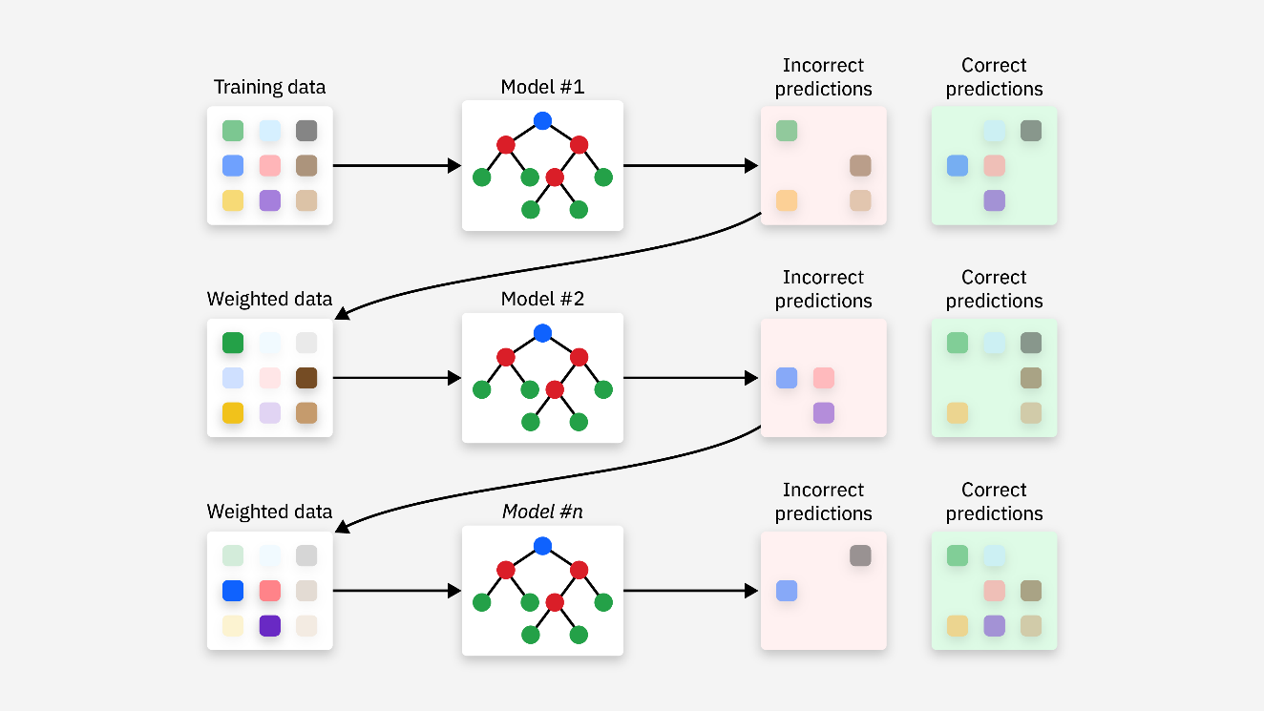
Fig. Boosting (Ensemble)
Classification Accuracy:
Classification accuracy is a fundamental metric for evaluating the performance of a classification model, providing a quick snapshot of how well the model is performing in terms of correct predictions. This is calculated as the ratio of correct predictions to the total number of input Samples.
Accuracy=No. of correct predictions/Total number of input samples​
Accuracy =TP+TN/(TP+FP+TN+FN)
It works great if there are an equal number of samples for each class. For example, we have a 90% sample of class A and a 10% sample of class B in our training set. Then, our model will predict with an accuracy of 90% by predicting all the training samples belonging to class A

we test the same model with a test set of 60% from class A and 40% from class B. Then the accuracy will fall, and we will get an accuracy of 60%.
Receiver Operating Characteristic curve (ROC-Area Under Curve)
It is one of the widely used metrics and basically used for binary classification. The AUC of a classifier is defined as the probability of a classifier will rank a randomly chosen positive example higher than a negative example. Before going into AUC more, a few basic terms.
True positive rate:
Also called or termed sensitivity. True Positive Rate is considered as a portion of positive data points that are correctly considered as positive, with respect to all data points that are positive.
TPR=TP/(TP+FN )
True Negative Rate
Also called or termed specificity. False Negative Rate is considered as a portion of negative data points that are correctly considered as negative, with respect to all data points that are negatives.
TNR=TN/(TN+FP )
False-positive Rate
False Negatives rate is actually the proportion of actual positives that are incorrectly identified as negatives
FPR=FP/(FP+TN)
A U C is a curve plotted between False Positive Rate Vs True Positive Rate at all different data points with a range of [0, 1]. Greater the value of AUC better the performance of the model.
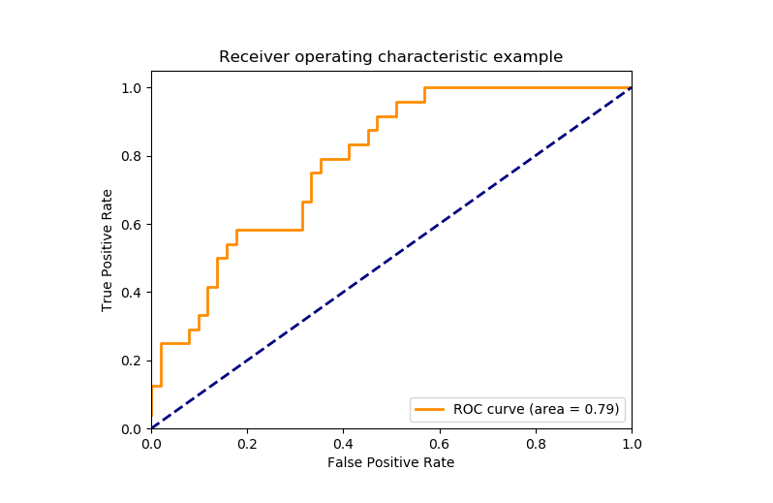
Fig. ROC Curve for Evaluation of Classification Models
0.5-0.6 ->Almost no predictive ability; 0.6-0.7 -> weak predictive ability
0.7-0.8 ->Fair predictive ability; 0.8-0.9 ->Good predictive ability: 0.9-1.0->Excellent predictive ability

F1 Score
It is a harmonic mean between recall and precision. Its range is [0,1]. This metric usually tells us how precise (It correctly classifies how many instances) and robust (does not miss any significant number of instances) our classifier is.
Precision
There is another metric named Precision. Precision is a measure of a model’s performance that tells you how many of the positive predictions made by the model are actually correct. It is calculated as the number of true positive predictions divided by the number of true positive and false positive predictions.
Precision=TP/(TP+FP​)
Recall
Recall=TP/(TP+FN)
Lower recall and higher precision give you great accuracy but then it misses a large number of instances. The more the F1 score better will be performance. It can be expressed mathematically in this way:
F1=2∗ precision * recall / (precision+ recall)
Confusion Matrix
It creates a N X N matrix, where N is the number of classes or categories that are to be predicted. Here we have N = 2, so we get a 2 X 2 matrix. Suppose there is a problem with our practice which is a binary classification. Samples of that classification belong to either Yes or No. So, we build our classifier which will predict the class for the new input sample. After that, we tested our model with 100 samples, and we get the following result.
Actual
Win Lost
Predicted Win | TP | FP
Lost | FN | TN

Actual Win = 60 Actual Lost=40
True Positives (TP)=40 True Negatives=30
False Positives (FP)=10 False Negatives=20

Regression Evaluation Metrics:
In the regression task, we are supposed to predict the target variable which is in the form of continuous values. To evaluate the performance of such a model below mentioned evaluation metrics are used:
- Mean Absolute Error
- Mean Squared Error
- Root Mean Square Error
- R2 – Score

Mean Absolute Error(MAE):
It is the average distance between Predicted and original values. Basically, it gives how we have predicted from the actual output. However, there is one limitation i.e. it doesn’t give any idea about the direction of the error which is whether we are under-predicting or over-predicting our data. It can be represented mathematically in this way:
MAE=(1/N) ∑_{j=1}^{N}∣yj−y^j∣
N- Number of observations; y^ -Predicted value; y-Actual value
Mean Squared Error (MSE):
It is similar to mean absolute error but the difference is it takes the square of the average of between predicted and original values. The main advantage to take this metric is here, it is easier to calculate the gradient whereas, in the case of mean absolute error, it takes complicated programming tools to calculate the gradient. By taking the square of errors, it pronounces larger errors more than smaller errors, we can focus more on larger errors. It can be expressed mathematically in this way.
MSE= (1/N) ∑_{j=1}^{N} (yj−y^j)²
Root Mean Square Error (RMSE):
We can say that RMSE is a metric that can be obtained by just taking the square root of the MSE value. As we know that the MSE metrics are not robust to outliers and so are the RMSE values. This gives higher weightage to the large errors in predictions.
RMSE = (1/N) ∑_{j=1}^{N} sqrt( (yj−y^j)²)
R-Squared (R2 score):The coefficient of determination also called the R2 score is used to evaluate the performance of a linear regression model. It is the amount of variation in the output-dependent attribute which is predictable from the input independent variable(s).

Model Prediction: Predictive modelling is a process used in data science to create a mathematical model that predicts an outcome based on input data. It involves using statistical algorithms and machine learning techniques to analyze historical data and make predictions
about future or unknown events.
Types of Predictive Models
There are several types of predictive models, each suitable for different types of data and problems. Here are some common types of predictive models:
- There are several types of predictive models, each suitable for different types of data and problems. Here are some common types of predictive models:
- Linear Regression: Linear regression is used when the relationship between the dependent variable and the independent variables is linear. It is often used for predicting continuous outcomes.
- Logistic Regression: Logistic regression is used when the dependent variable is binary (i.e., has two possible outcomes). It is commonly used for classification problems.
- Decision Trees: Decision trees are used to create a model that predicts the value of a target variable based on several input variables. They are easy to interpret and can handle both numerical and categorical data.
- Random Forests: Random forests are an ensemble learning method that uses multiple decision trees to improve the accuracy of the predictions. They are robust against overfitting and can handle large datasets with high dimensionality.
- Support Vector Machines (SVM): SVMs are used for both regression and classification tasks. They work well for complex, high-dimensional datasets and can handle non-linear relationships between variables.
- Neural Networks: Neural networks are a class of deep learning models inspired by the structure of the human brain. They are used for complex problems such as image recognition, natural language processing, and speech recognition.
- Gradient Boosting Machines: Gradient boosting machines are another ensemble learning method that builds models sequentially, each new model correcting errors made by the previous ones. They are often used for regression and classification tasks.
- Time Series Models: Time series models are used for predicting future values based on past observations. They are commonly used in finance, economics, and weather forecasting.

Search, Learning Datasets:
UCI Machine Learning Repository
This is the ML community that was first created by a researcher at the University of Irvine, California, and distributes various datasets that cover diverse domains. In addition to this, the datasets are available in various formats with detailed documentation that helps the ML audience to understand the data well. So, it is a valuable resource for both beginner and experienced users in the field.
Dataset link - Iris Dataset
Kaggle
The Kaggle is very popular among all its competitive resources. It is an online platform that involves a community of data scientists, ML engineers, and researchers. This offers a variety of tools and resources to support the project based on data science, competitions, and other collaborative learning. The Kaggle website hosts a vast collection of datasets which used in various domains such as image recognition, natural language processing, tabular data, and more. These resources can be retrieved and downloaded by any user to use for their project.
On the website of Kaggle, you can get the chance to learn ML courses, Python, etc.
Dataset link - Housing Dataset
Open Data on AWS
The AWS dataset is publicly available to users to download and access it. The AWS is known for cloud-based access to facilitate research, analysis, and experimentation. The datasets are often contributed by researchers and institutions or universities. The goal of AWS is to innovate unique research in the field of ML and data science communities.
Dataset link - Amazon-Products DataSet
Google Dataset Search
The Google dataset is primarily used in every institution, universities and organizations.
Dataset link - RTA Dataset
Azure Open Datasets
The Azure is known for cloud based platform and it is hosted by the company Microsoft. The datasets present is azure platform used by various domains such as Finance, Healthcare, Environmental Science and more. Due to cloud technology it also used for deployment of ML project
Dataset link - Air Conditioners Dataset

Earthdata
The Earthdata is full of open access datasets organized by the company NASA. It is used for data collection and promoting scientific progress for societal benefit.
Dataset link - Environment_Temperature_change_E_All_Data_NOFLAG
Github
GitHub serves as a hub for individuals to exchange Machine Learning datasets resembling a library housing sets of data vital, for training and evaluating AI models.
Dataset link - Food Report
Government Open Data Portals
This is government based site which is used by public users. The main goal of these datasets aim to promote innovation of technology, business prediction, accountability, etc. These datasets can be used by developer, citizen, and businesses to access government generated data.
Dataset link - country_wise_dataset

UNIT 2 - Nearest Neighbor-Based Models: Introduction to Proximity Measures, Distance Measures, Non-Metric Similarity Functions, Proximity Between Binary Patterns, Different Classification Algorithms Based on the Distance Measures, K-Nearest Neighbor Classifier, Radius Distance Nearest Neighbor Algorithm, KNN Regression, Performance of Classifiers, Performance of Regression Algorithms.
Proximity Measures
Used to quantify the degree of similarity or dissimilarity between two or more patterns.
• Types:
➢Euclidean distance: This the most popular distance as it is intuitively appealing. It measures the straight-line distance between two points in a multidimensional space.
➢Cosine similarity: This measures the cosine of the angle between two vectors and is often used in text analysis to compare documents. If the similarity value is 1, the angle between x and y is 0 deg. Which means x and y are same except for the magnitude. If the similarity value is 0, the angle between x and y is 90 deg. Which means x and y have no similarities (in case of text data, no term/word is common).
➢Jaccard similarity: This measures the intersection over union of two sets and is often used in recommendation systems to compare users’ preferences.
J=n11/(n01+n10+n11)
J is a jaccard coefficient measures
Jaccarad distance dJ=1-J
n11= number of cases both features have the value 1
n01= number of cases F1 value is 0 and F2 value is 1
n10= number of cases F1 value is 1 and F2 value is 0
Simple matching coefficient(SMC)
SMC of F1 and F2= n11+n00/(n00+n01+n10+n11)
➢Hamming distance: This measures the number of positions at which two binary strings differ and is often used in error correction codes.
For example, the Hamming distance between two vectors 01101011,11001001 is 3
0 1 1 0 1 0 1 1
1 1 0 0 1 0 0 1
1 1 1 = 3

Distance Measures: Used to find the dissimilarity between pattern representations.
Key attributes of distance measures:
Positive reflexivity: d(x,x) = 0
Symmetry: d(x,y) = d(y,x)
Triangular inequality: d(x,y)< d(x,z) + d(z,y)
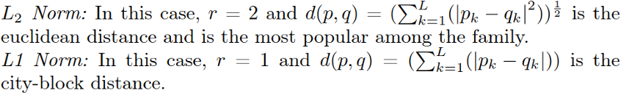
Non-Metric Similarity Functions:
This category includes similarity functions that do not follow the triangular inequality or symmetry.
They are commonly used for image or string data, and they are resistant to outliers or extremely noisy data.
• Example: k-median distance between two vectors.
➢Given x = (x1, x2, · · · , xn) and y = (y1, y2, · · · , yn), the formula for the k-median distance is d(x, y) = k-median {|x1 y1|, · · · , |xn yn|}, where the k-median operator returns the kth value of the ordered difference vector.
• Example: Cosine similarity between two vectors x and y
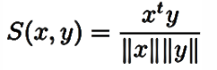
Or
Cos(x, y) = x. y/ (||x||.||y|| )

Proximity Between Binary Patterns:
Let p and q be two binary strings. Some of the popular proximity measures on such binary patterns are:
➢Hamming Distance (HD): If pi = qi then we say that p and q match on their ith bit, else (pi != qi) p and q mismatch on the i th bit. Hamming distance is the number of mismatching bits out of the 1-bit locations.

➢Simple Matching Coefficient (SMC):
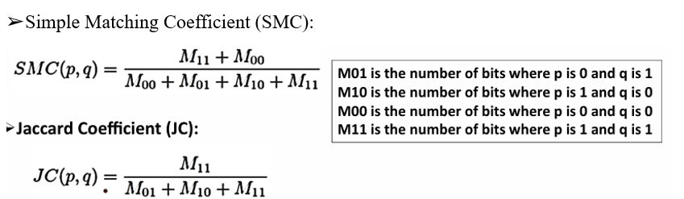

Different classification algorithms based on the distance measures:
K-Nearest Neighbor Classifier
K-NN is a non-parametric algorithm, which means it does not make any assumption on underlying data.
It is also called a lazy learner algorithm because it does not learn from the training set immediately instead it stores the dataset and at the time of classification, it performs an action on the dataset.
KNN algorithm at the training phase just stores the dataset and when it gets new data, then it classifies that data into a category that is much similar to the new data.
o Example: Suppose, we have an image of a creature that looks similar to cat and dog, but we want to know either it is a cat or dog. So for this identification, we can use the KNN algorithm, as it works on a similarity measure. Our KNN model will find the similar features of the new data set to the cats and dogs images and based on the most similar features it will put it in either cat or dog category.
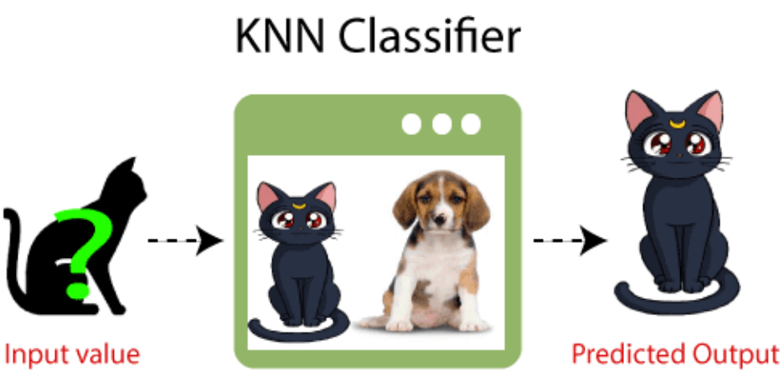
Need of K-NN Algorithm: Suppose there are two categories, i.e., Category A and Category B, and we have a new data point x1, so this data point will lie in which of these categories. To solve this type of problem, we need a K-NN algorithm. With the help of K-NN, we can easily identify the category or class of a particular dataset. Consider below diagram.

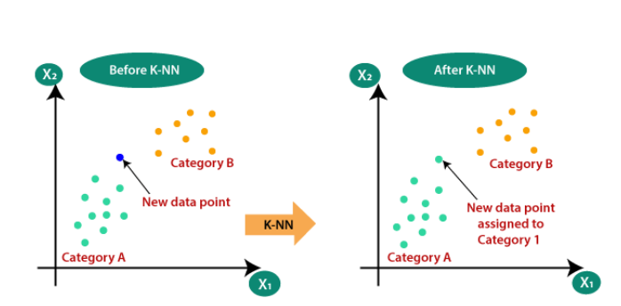
KNN Algorithm:
Step-1: Select the number K of the neighbours
Step-2: Calculate the Euclidean distance of K number of neighbours
Step-3: Take the K nearest neighbours as per the calculated Euclidean distance.
Step-4: Among these k neighbours, count the number of the data points in each category.
Step-5: Assign the new data points to that category for which the number of the neighbour is maximum.
Step-6: Our model is ready.
Suppose we have a new data point and we need to put it in the required category. Consider the below image.

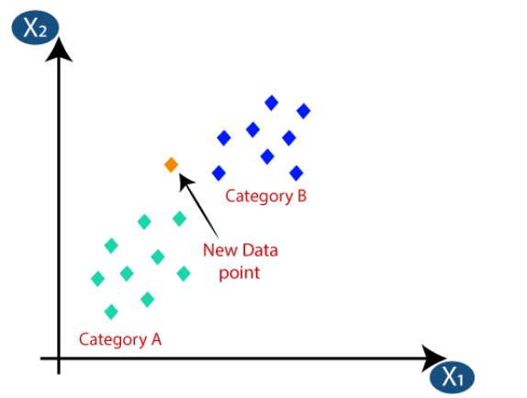 | 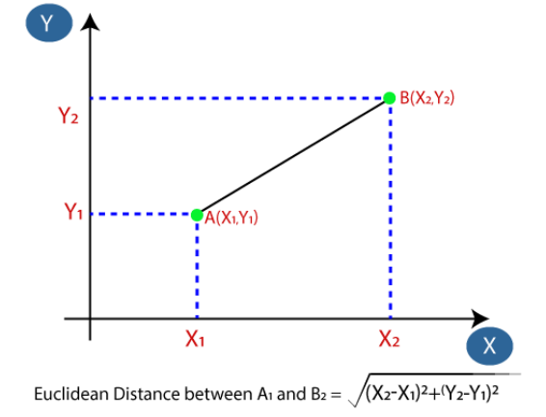 | 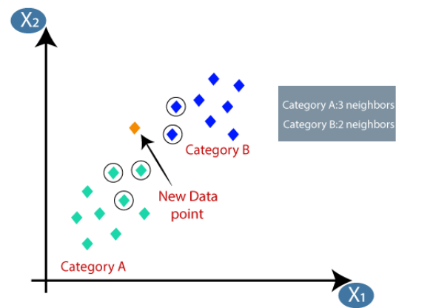
i | ii | iii

Firstly, choose the number of neighbours, so we will choose the k=5.
Next, we will calculate the Euclidean distance between the data points. The Euclidean distance is the distance between two points, which we have already studied in geometry. It can be calculated as: By calculating the Euclidean distance we got the nearest neighbours, as three nearest neighbours in category A and two nearest neighbours in category B.

Consider as we can see the 3 nearest neighbours are from category A, hence this new data point must belong to category A.
Selecting the value of K in the K-NN algorithm:
o There is no particular way to determine the best value for "K", so we need to try some values to find the best out of them. The most preferred value for K is 5.
o A very low value for K such as K=1 or K=2, can be noisy and lead to the effects of outliers in the model.
o Large values for K are good, but it may find some difficulties.
Advantages of KNN Algorithm:
o It is simple to implement.
o It is robust to the noisy training data
o It can be more effective if the training data is large.
Disadvantages of KNN Algorithm:
o Always needs to determine the value of K which may be complex some time.
o The computation cost is high. (because of calculating the distance between the data points for all the training samples.)

Radius Distance Nearest Neighbor Algorithm: Radius Neighbours Classifier is a classification machine learning algorithm.
It is an extension to the k-nearest neighbours algorithm that makes predictions using all examples in the radius of a new example rather than the k-closest neighbours.
As such, the radius-based approach to selecting neighbours is more appropriate for sparse data, preventing examples that are far away in the feature space from contributing to a prediction.
Radius Neighbors Classifier -> machine learning algorithm
Algorithm Steps
- Input:
  - Dataset D: {x1,x2,…,xn}
  - Query point q
  - Radius r
  - Distance metric d

- Search for Neighbours:
  - Compute d(q, xi) for each xi ∈ D.
  - Select all points xi​ such that d(q, xi)≤ r .
- Output:
  - Return the set of neighbours within radius r.

KNN Regression :
KNN regression is a non-parametric method used for predicting continuous values. The core idea is to predict the target value for a new data point by averaging the target values of the K nearest neighbors in the feature space. The distance between data points is typically measured using Euclidean distance, although other distance metrics can be used.
Working of KNN Algorithm:
- Choosing the number of neighbors (K): The initial step involves selecting the number of neighbors, K. This choice greatly affects the model's performance. A smaller value of K makes the model more prone to noise, whereas a larger value of K results in smoother predictions.
- Calculating distances: For a new data point, calculate the distance between this point and all points in the training set.
- Finding K nearest neighbors: Identify the K points in the training set that are closest to the new data point.
- Predicting the target value: Compute the average of the target values of the K nearest neighbors and use this as the predicted value for the new data point.

Performance of Classifiers :
Classification Metrics in Machine Learning
Classification Metrics is about predicting the class labels given input data. In binary classification, there are only two possible output classes(i.e., Dichotomy). In multiclass classification, more than two possible classes can be present. I’ll focus only on binary classification.
A very common example of binary classification is spam detection, where the input data could include the email text and metadata (sender, sending time), and the output label is either “spam” or “not spam.” (See Figure) Sometimes, people use some other names also for the two classes: “positive” and “negative,” or “class 1” and “class 0.”

Performance of Regression Algorithms.

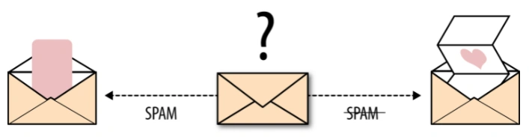
Fig. Email spam detection is a binary classification problem( Machine Learning Model — O’Reilly)

There are many ways for measuring classification performance. Accuracy, confusion matrix, log-loss, and AUC-ROC are some of the most popular metrics. Precision-recall is a widely used metrics for classification problems.
Performance Metrics for Regression
Regression is a supervised learning technique that aims to find the relationships between the dependent and independent variables. A predictive regression model predicts a numeric or discrete value. The metrics used for regression are different from the classification metrics. It means we cannot use the Accuracy metric (explained above) to evaluate a regression model; instead, the performance of a Regression model is reported as errors in the prediction. Following are the popular metrics that are used to evaluate the performance of Regression models.
- Mean Absolute Error
- Mean Squared Error
- R2 Score
- Root Mean Squared Error

Y is the Actual outcome, Y' is the predicted outcome, and N is the total number of data points.
MAE is much more robust for the outliers. One of the limitations of MAE is that it is not differentiable, so for this, we need to apply different optimizers such as Gradient Descent. However, to overcome this limitation, another metric can be used, which is Mean Squared Error or MSE.
Mean Squared error or MSE is one of the most suitable metrics for Regression evaluation. It measures the average of the Squared difference between predicted values and the actual value given by the model.


Y is the Actual outcome, Y' is the predicted outcome, and N is the total number of data points.
R squared error is also known as Coefficient of Determination, which is another popular metric used for Regression model evaluation.
The R squared score will always be less than or equal to 1 without concerning if the values are too large or small.
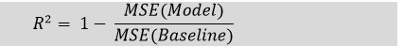

UNIT-3
UNIT-III: Models Based on Decision Trees: Decision Trees for Classification, Impurity Measures, properties, Regression Based on Decision Trees, Bias–Variance Trade-off, Random Forests for Classification and egression.
The Bayes Classifier: Introduction to the Bayes Classifier, Bayes’ Rule and Inference, The Bayes Classifier and its Optimality, Multi-Class Classification | Class Conditional Independence and Naive Bayes Classifier (NBC)

1. Bayes’ Theorem
P(A|B)=P(B|A)×P(A)P(B)
Where:
P(A|B): Posterior probability – the revised probability of event A occurring after observing event B.
P(A): Prior probability – our initial belief in A, prior to the new evidence B.
P(B|A): Likelihood – the odds of witnessing the evidence B, assuming A is valid.
P(B): Marginal likelihood or evidence – the overall probability of seeing evidence B.
1.1. Three Pillars of Bayesian Inference:
- Prior(P(A)):
Represents our pre-existing knowledge or belief about an event before new data.
- Likelihood(P(B|A)):
Depicts how well our data matches our predictions.
- Posterior(P(A|B)):
Our updated belief after integrating the new evidence. It evolves from the prior and the likelihood.
2. Bayesian Inference
Bayesian inference is about harnessing the prior and likelihood to determine the posterior. It’s essentially about refreshing our beliefs (priors) with new data (likelihood).
Its iterative nature is commendable. As new data surfaces, the posterior probability from one step can serve as the prior for the subsequent step. This iterative method sharpens our inferences with accumulating evidence.
Example: A rare disease affecting 1% of a population and a test that’s 99% accurate. If you test positive, what’s the likelihood you truly have the disease?
Given:
Prior P(Disease) = 0.01 (Initial belief about the prevalence of the disease).

Likelihood P(Positive|Disease) = 0.99 (Chances of testing positive if you indeed have the disease).
Marginallikelihood P(Positive) = P(Disease)×P(Positive|Disease) + P(NoDisease)×P(Positive|NoDisease) = 0.0198.
Using Bayes’ theorem, the posterior
P(Disease| Positive)=0.99×0.01 / 0.0198=0.4995
Even with a positive result from a 99% accurate test, there’s only a 49.95% chance of genuinely having the disease.
Naive Bayes Classifier: A simple yet effective method, especially potent in text classification tasks such as spam detection and sentiment analysis.
- Bayesian Networks: Probabilistic graphical models capturing complex relationships among variables, applied in diagnostics, genetics, and some NLP tasks.
- Bayesian Optimization: An optimization technique applied to efficient hyperparameter tuning, replacing random or grid search methods.
- Statistical Modeling: Bayesian methods infer parameter values, especially useful where data is sparse or noisy.
- Recommender Systems: Bayesian techniques, like Bayesian Personalized Ranking, offer tailored recommendations to users.
- Bayesian Deep Learning: Merges deep neural networks with probabilistic models, allowing networks to quantify uncertainty about predictions.
- Anomaly Detection: Bayesian methods model expected behavior, effectively identifying anomalies in new data.

Bayes Optimal Classifier and Naive Bayes Classifier
The Bayes Optimal Classifier is a probabilistic model that predicts the most likely outcome for a new situation. In this blog, we’ll have a look at Bayes optimal classifier and Naive Bayes Classifier.
The Bayes theorem is a method for calculating a hypothesis’s probability based on its prior probability, the probabilities of observing specific data given the hypothesis, and the seen data itself.
BAYES OPTIMAL CLASSIFIER
The Bayes Theorem, which provides a systematic means of computing a conditional probability, is used to describe it. It’s also related to Maximum a Posteriori (MAP), a probabilistic framework for determining the most likely hypothesis for a training dataset.

Take a hypothesis space that has 3 hypotheses h1, h2, and h3.
The posterior probabilities of the hypotheses are as follows:
h1 = 0.4
h2 = 0.3
h3 = 0.3
Hence, h1 is the MAP hypothesis. (MAP => max posterior)
Suppose a new instance x is encountered, which is classified negative by h2 and h3 but positive by h1.
C_{MAP} = max Σ P(c _{i} / T)
max Σ P(c _{i} / T) = max Σ P(c _{i} / h_{i}) P(h_{i} /T)
P(h1/T)=0.4 P((True/h1)=1, P((False/h1)=0
P(h2/T)=0.3 P((True/h2)=0, P((False/h2)=1
P(h3/T)=0.3 P((True/h3)=0, P((False/h3)=1
For ci=True, hypothesis h1, h2, h3, => Σ P(c _{i} / h_{i}) P(h_{i} /T)= 0.4
For ci=False, hypothesis h1, h2, h3, => Σ P(c _{i} / h_{i}) P(h_{i} /T)= 0.3 + 0.3=0.6
Max Σ P(c _{i} / h_{i}) P(h_{i} /T) =0.6
C_{MAP} = max Σ P(c _{i} / T) =Negative
Taking all hypotheses into account, the probability that x is positive is 0 .4 and the probability that it is negative is therefore 0.6.
The classification generated by the MAP hypothesis is different from the most probable classification in this case which is negative.
The most probable classification of the new instance is obtained by combining the predictions of all hypotheses, weighted by their posterior probabilities.
Multi-Class or Class Conditional Independence:
Multi-Class or Class Conditional Independence in machine learning refers to the assumption that features are conditionally independent given the class label. This is a key assumption in models like Naïve Bayes.
Explanation:
- Given a class label C, the features X1,X2,…,Xn are assumed to be independent of each other.
- Mathematically, this means: P(X1,X2,...,Xn∣C)=P(X1∣C)P(X2∣C)...P(Xn∣C)

- This simplifies computations in probabilistic models like Naïve Bayes, making them scalable and efficient.
usefulness
- It works well in practice for text classification, spam detection, and sentiment analysis despite being a strong assumption.
- However, in cases where features are highly dependent, more complex models like decision trees or deep learning may perform better.
Multi-Class or Class Conditional Independence in Machine Learning
Class Conditional Independence (CCI) is a simplifying assumption used in probabilistic models, particularly Naïve Bayes classifiers. It assumes that given the class label, the features are independent of each other.
Let:
- X=(X1,X2,...,Xn) be the feature vector (input variables).
- C be the class label (output variable).
Under the class conditional independence assumption, the joint probability of all features given the class is:
P(X1, X2,...,Xn∣C)=P(X1∣C) P(X2∣C)... P(Xn∣C)
This means that once we know the class, the features no longer depend on each other.
Without this assumption, computing P(X∣C) would require estimating all possible feature dependencies, which is often impractical for large datasets.
With CCI, we only need to estimate the individual probabilities P(Xi∣C) reducing complexity significantly.
Applications
Naïve Bayes often perform surprisingly well in real-world problems, such as:
Spam Detection: Classifying emails as spam/not spam.
Text Classification: Sentiment analysis, topic classification, etc.
Medical Diagnosis: Predicting diseases based on symptoms.
Example: Naïve Bayes Classifier for Email Spam Detection
Suppose we classify emails as Spam (S) or Not Spam (¬S) using three features:
- X1: Presence of the word “money”

- X2: Presence of “free”
- X3: Presence of “urgent”
Using Bayes’ Theorem:
P(S∣X1,X2,X3)=P(X1,X2,X3∣S)P(S)/P(X1,X2,X3)
With class conditional independence:
P(X1,X2,X3∣S)=P(X1∣S)P(X2∣S)P(X3∣S)
This drastically simplifies calculations.
Naive Bayes Classifier
Naive Bayes Classifier is a supervised algorithm in machine-learning which uses the Bayes Theorem. The theorem depends on the assumption that input variables are independent of each other. Irrespective of this assumption, it has proven to be a classifier with better results.
Naive Bayes (NB) algorithm is naive because it makes the assumption that features are independent of each other. This is naive because it is almost never true.
Naive Bayes classifier assumes that the existence of a particular feature of a class is unrelated to the presence or absence of any other feature, in the given the class variable.
Naive Bayes Classifiers basically depends on the Bayes’ Theorem, which is based on conditional probability. The likelihood that an event (A) will occur given that another event (B) has already occurred. Basically, the theorem allows a hypothesis to be updated every time new evidence is introduced. The equation below explains Bayes Theorem:
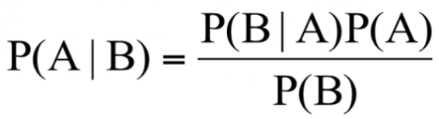
Let’s explain each of these terms,
“P” is the symbol to denote probability.
P(A | B) = The probability of event A (hypothesis) occurring given that B (evidence) has occurred.
P(B | A) = The probability of the event B (evidence) occurring given that A (hypothesis) has occurred.
P(A) = The probability of event B (hypothesis) occurring.
P(B) = The probability of event A (evidence) occurring.

Class Probabilities: The probabilities of each class in the training dataset.
Conditional Probabilities: The conditional probabilities of each input value for every given class value.
To perform Naïve-Bayes classification, the dataset is divided into two parts, namely, feature matrix and the response vector.
Feature matrix contains all the vectors(rows) of dataset in which every vector consists of the value of dependent features.
Response vector contains the value of class variable either prediction or output for each row of feature matrix.
Prior Probability
A prior probability is the probability that an observation will fall into a category before you collect the data.
Posterior Probability
A posterior probability is the probability of assigning observations to categories or groups given in the data.
From Bayes’ theorem we can relate the two as

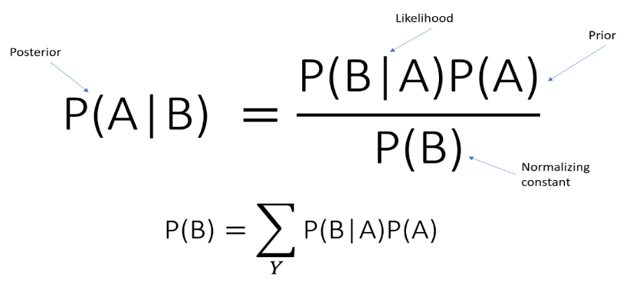

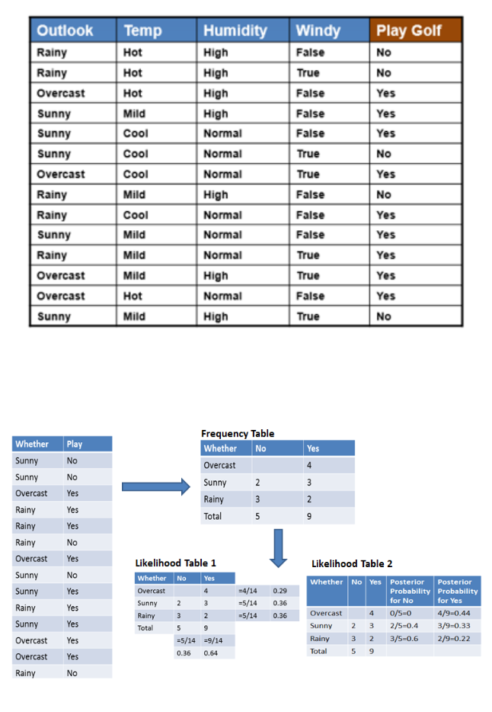

Types of Naïve Bayes Classifiers
There are three types of classifiers. They are
- Gaussian Naïve Bayes- Gaussian Naive Bayes is useful when we are working with continuous values whose probabilities can be modeled using a Gaussian distributi
- Multinomial Naïve Bayes- A multinomial distribution is helpful to model feature vectors where each value represents like the number of occurrences of a term or its relative frequency. If the feature vectors have n elements and each element of them can assume k different values with probability pk
- Bernoulli Naïve Bayes- If X is a random variable which is Bernoulli-distributed, it assumes only two values and their probability is given as follows
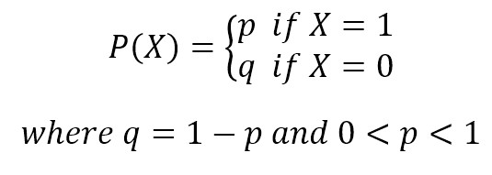
Decision Tree:
- Decision Tree is a supervised learning algorithm which can be used for solving both classification and regression problems.
- It can solve problems for both categorical and numerical data
- Decision Tree regression builds a tree-like structure in which each internal node represents the "test" for an attribute, each branch represent the result of the test, and each leaf node represents the final decision or result.
- A decision tree is constructed starting from the root node/parent node (dataset), which splits into left and right child nodes (subsets of dataset). These child nodes are further divided into their children node, and themselves become the parent node of those nodes.
Consider the below image:

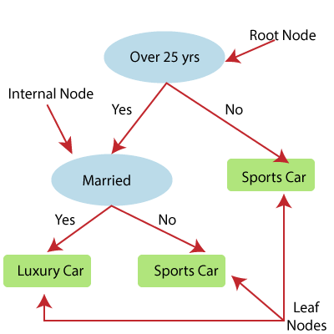
Fig. Decision Tree
Decision Tree Classification Algorithm
Decision Tree is a Supervised learning technique that can be used for both classification and Regression problems, but mostly it is preferred for solving Classification problems. It is a tree-structured classifier, where internal nodes represent the features of a dataset, branches represent the decision rules and each leaf node represents the outcome.

- In a Decision tree, there are two nodes, which are the Decision Node and Leaf Node. Decision nodes are used to make any decision and have multiple branches, whereas Leaf nodes are the output of those decisions and do not contain any further branches.
- The decisions or the test are performed on the basis of features of the given dataset.
- It is a graphical representation for getting all the possible solutions to a problem/decision based on given conditions.
- It is called a decision tree because, similar to a tree, it starts with the root node, which expands on further branches and constructs a tree-like structure.
- In order to build a tree, we use the CART algorithm, which stands for Classification and Regression Tree algorithm.
- A decision tree simply asks a question, and based on the answer (Yes/No), it further split the tree into subtrees.
- Below diagram explains the general structure of a decision tree:
Note: A decision tree can contain categorical data (YES/NO) as well as numeric data.

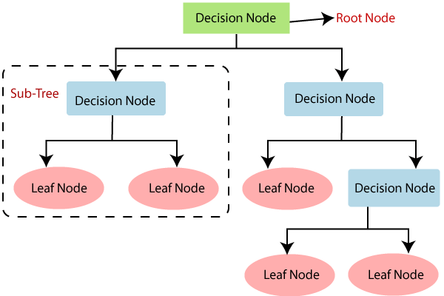

There are various algorithms in Machine learning, so choosing the best algorithm for the given dataset and problem is the main point to remember while creating a machine learning model. Below are the two reasons for using the Decision tree:
- Decision Trees usually mimic human thinking ability while making a decision, so it is easy to understand.
- The logic behind the decision tree can be easily understood because it shows a tree-like structure.
Decision Tree Terminologies
Root Node: Root node is from where the decision tree starts. It represents the entire dataset, which further gets divided into two or more homogeneous sets.
Leaf Node: Leaf nodes are the final output node, and the tree cannot be segregated further after getting a leaf node.
Splitting: Splitting is the process of dividing the decision node/root node into sub-nodes according to the given conditions.
Branch/Sub Tree: A tree formed by splitting the tree.
Pruning: Pruning is the process of removing the unwanted branches from the tree.
Parent/Child node: The root node of the tree is called the parent node, and other nodes are called the child nodes.
Working of Decision Tree Algorithm:
In a decision tree, for predicting the class of the given dataset, the algorithm starts from the root node of the tree. This algorithm compares the values of root attribute with the record (real dataset) attribute and, based on the comparison, follows the branch and jumps to the next node.

For the next node, the algorithm again compares the attribute value with the other sub-nodes and move further. It continues the process until it reaches the leaf node of the tree.
Algorithm:
Step1: Begin the tree with the root node, says S, which contains the complete dataset.
Step2: Find the best attribute in the dataset using Attribute Selection Measure (ASM).
Step 3: Divide the S into subsets that contains possible values for the best attributes.
Step 4: Generate the decision tree node, which contains the best attribute.
Step-5: Recursively make new decision trees using the subsets of the dataset created in step -3. Continue this process until a stage is reached where you cannot further classify the nodes and called the final node as a leaf node.
Example: Suppose there is a candidate who has a job offer and wants to decide whether he should accept the offer or Not. So, to solve this problem, the decision tree starts with the root node (Salary attribute by ASM). The root node splits further into the next decision node (distance from the office) and one leaf node based on the corresponding labels. The next decision node further gets split into one decision node (Cab facility) and one leaf node. Finally, the decision node splits into two leaf nodes (Accepted offers and Declined offer). Consider the below diagram:
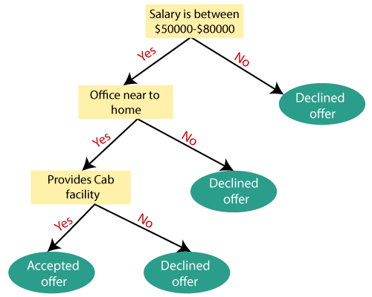
Impurity Measures OR Attribute Selection Measures:
While implementing a Decision tree, the main issue arises that how to select the best attribute for the root node and for sub-nodes. So, to solve such problems there is a technique which is called as Attribute selection measure or ASM. By this measurement, we can easily select the best attribute for the nodes of the tree.

There are two popular techniques:
1. Information Gain:
- Information gain is the measurement of changes in entropy after the segmentation of a dataset based on an attribute.
- It calculates how much information a feature provides us about a class.
- According to the value of information gain, we split the node and build the decision tree.
- A decision tree algorithm always tries to maximize the value of information gain, and a node/attribute having the highest information gain is split first. It can be calculated using the below formula:
Information Gain= Entropy(S)- [(Weighted Avg) *Entropy(each feature)
Entropy: Entropy is a metric to measure the impurity in a given attribute. It specifies randomness in data. Entropy can be calculated as:
Entropy(s)= -P(yes)log2 P(yes)- P(no) log2 P(no)
Where,
S= Total number of samples
P(yes)= probability of yes
P(no)= probability of no
2. Gini Index:
Gini index is a measure of impurity or purity used while creating a decision tree in the CART(Classification and Regression Tree) algorithm.
An attribute with the low Gini index should be preferred as compared to the high Gini index.
It only creates binary splits, and the CART algorithm uses the Gini index to create binary splits.
Gini Index= 1- ∑_{j}P_{j}² where pi​ is the probability of an object being classified to a particular class.
Pruning: Getting an Optimal Decision tree
Pruning is a process of deleting the unnecessary nodes from a tree in order to get the optimal decision tree.
A too-large tree increases the risk of overfitting, and a small tree may not capture all the important features of the dataset. Therefore, a technique that decreases the size of the learning tree without

reducing accuracy is known as Pruning. There are mainly two types of tree pruning technology used: Pre Pruning and Post Pruning

Decision Tree Regression : It predicts continuous values. It does this by splitting the data into smaller subsets based on decision rules derived from the input features. Each split is made to minimize the error in predicting the target variable. At leaf node of the tree the model predicts a continuous value which is typically the average of the target values in that node.
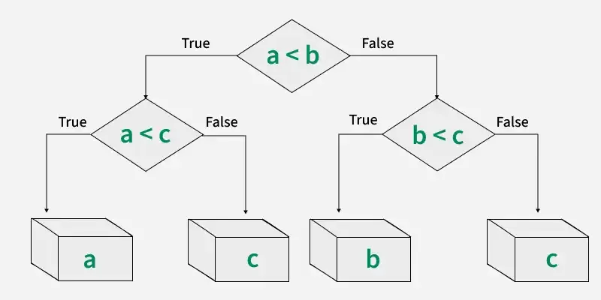
Fig. Workflow of Decision Tree Regression
Branches connect nodes and represent the outcome of a decision. For example, if the answer to a condition is “Yes,” you follow one branch; if “No,” you follow another.
Bias Variance Tradeoff:
The bias is known as the difference between the prediction of the values by the Machine Learning model and the correct value.

The variability of model prediction for a given data point which tells us the spread of our data is called the variance of the model.
If the algorithm is too simple (hypothesis with linear equation) then it may be on high bias and low variance condition and thus is error-prone. If algorithms fit too complex (hypothesis with high
degree equation) then it may be on high variance and low bias. In the latter condition, the new entries will not perform well. Well, there is something between both of these conditions, known as a Trade-off or Bias Variance Trade-off. This trade-off in complexity is why there is a trade-off between bias and variance. For the graph, the perfect trade-off will be like this.
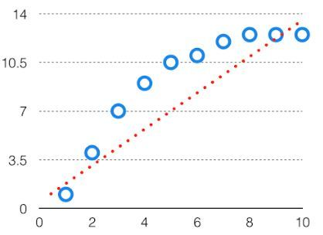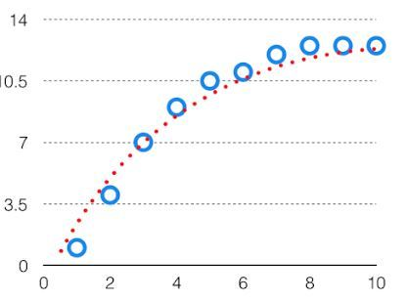
Fig. High Bias in a model Fig. Perfect fit of a model
The best fit will be given by the hypothesis on the tradeoff point. The error to complexity graph to show trade-off is given as –
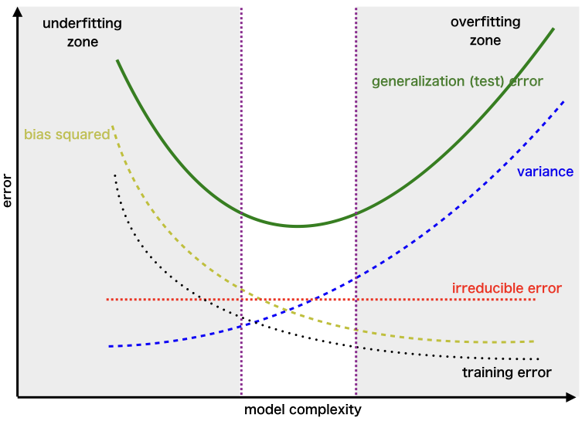
Fig. Bias vs Variance Tradeoff

Random forest algorithm:
Random forest, a popular machine learning algorithm developed by Leo Breiman and Adele Cutler, merges the outputs of numerous decision trees to produce a single outcome. Its popularity stems from its user-friendliness and versatility, making it suitable for both classification and regression tasks.
One of the most important features of the Random Forest Algorithm is that it can handle the data set containing continuous variables, as in the case of regression, and categorical variables, as in the case of classification. It performs better for classification and regression tasks.
Random Forest Applications
1. Customer churn prediction: Businesses can use random forests to predict which customers are likely to churn (cancel their service) so that they can take steps to retain them. For example, a telecom company might use a random forest model to identify customers who are using their phone less frequently or who have a history of late payments.
2. Fraud detection: Random forests can identify fraudulent transactions in real-time. For instance, a bank might employ a random forest model to spot transactions made from unusual locations or involving unusually large amounts of money.
3. Stock price prediction: It can predict future stock prices. However, it is important to note that stock price prediction is a very difficult task, and no model is ever going to be perfectly accurate.
4. Medical diagnosis: These can help doctors diagnose diseases. For example, a doctor might use a random forest model to help them diagnose a patient with cancer.
5. Image recognition: It can recognize objects in images. For example, a self-driving car might use a random forest model to identify pedestrians and other vehicles on the road.
Algorithm:
Step 1: In this model, we select a subset of data points and a subset of features to construct each decision tree. Simply put, we take n random records and m features from a dataset containing k records.
Step 2: We construct individual decision trees for each sample.
Step 3: Each decision tree will generate an output.
Step 4: We consider the final output based on Majority Voting for classification and Averaging for regression, respectively.

For example: Consider the fruit basket as the data as shown in the figure below. Now n number of samples are taken from the fruit basket, and an individual decision tree is constructed for each sample. Each decision tree will generate an output, as shown in the figure. The final output based on majority voting. In the figure below, you can see that the
majority decision tree outputs an apple compared to a banana, so we take the final output as an apple.
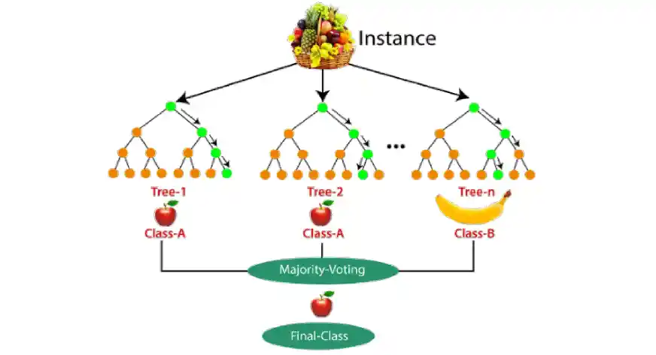
Difference Between Decision Tree and Random Forest
Random forest is a collection of decision trees; still, there are a lot of differences in their behaviour.
Random Forest Regression:
Random Forest Regression works by creating multiple of decision trees each trained on a random subset of the data. The process begins with Bootstrap sampling where random rows of data are selected with replacement to form different training datasets for each tree. After this we do feature sampling where only a random subset of features is used to build each tree ensuring diversity in the models. After the trees are trained each tree make a prediction and the final prediction for

regression tasks is the average of all the individual tree pred ictions and this process is called as Aggregation.
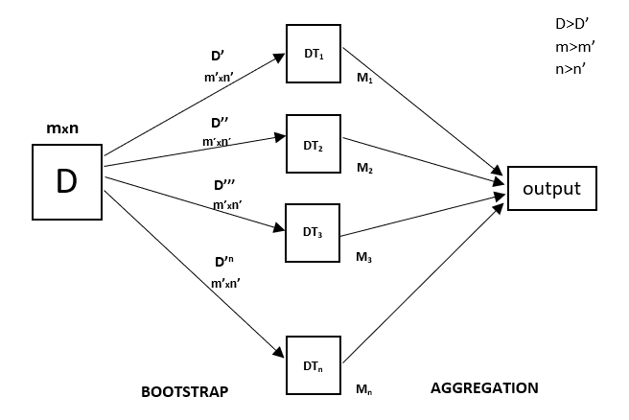
Fig. Random Forest Regression Model Working

UNIT-IV: Linear Discriminants for Machine Learning: Introduction to Linear Discriminants, Linear Discriminants for Classification, Perceptron Classifier, Perceptron Learning Algorithm, Support Vector Machines, Linearly Non-Separable Case, Non-linear SVM, Kernel Trick, Logistic Regression, Linear Regression, Multi-Layer Perceptrons (MLPs), Backpropagation for Training an MLP.
Introduction to Linear Discriminants:
Linear discriminants are used in machine learning and statistics for classification tasks. They find a linear boundary (hyperplane) to separate different classes in the data. The goal is to maximize class separability while minimizing variance within each class.
Linear Discriminants for Classification:
A linear function is used to project high-dimensional data onto a lower-dimensional space while preserving class differences.
Linear Discriminant Analysis (LDA) is One of the most common methods using linear discriminants. It finds a projection that maximizes the ratio of between-class variance to within-class variance.
Mathematical Formulation: Given data points X with class labels, LDA finds a transformation W that projects data onto a new axis where classes are best separated.
Optimal W is found by solving: W= (S_{W} )⁻¹ S_{B} where:
S_{W} = within-class scatter matrix S_{B} = between-class scatter matrix

LDA is a supervised method (uses class labels). where as PCA is unsupervised (only focuses on variance, not class separation).
Applications: 1. Pattern recognition 2. Face recognition 3. Medical diagnosis 4.Text classification
Limitations: Assumes normally distributed data and equal class covariance. Struggles with complex, non-linearly separable data.
Perceptron Classifier:
Definition: A perceptron is a simple type of artificial neural network used for binary classification. It finds a linear decision boundary to separate two classes.
The original Perceptron was designed to take a number of binary inputs, and produce one binary output (0 or 1).The idea was to use different weights to represent the importance of each input, and that the sum of the values should be greater than a threshold value before making a decision like yes or no (true or false) (0 or 1).
Consists of input features, weights, bias, and an activation function (step function).
  - Computes weighted sum: 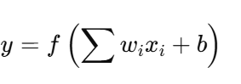 where:
    - x_{i} = input features
    - w_{i}= weights
    - b = bias
    - f = activation function (step function)

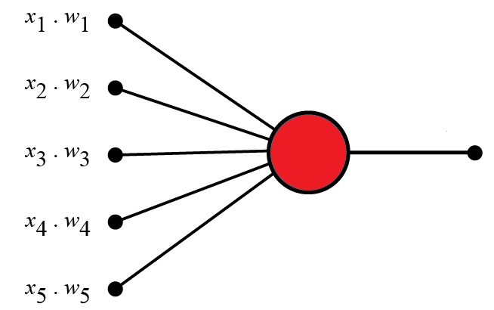
Fig. Perceptron
2. Learning Algorithm (Perceptron Learning Rule)
1. Set a threshold value
2. Multiply all inputs with Starts with random weights.
3. Sum all the results
4. Activate the output
Updates weights iteratively using the rule: where
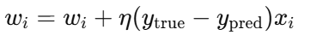
    - η = learning rate
    - y_{true} = actual class label
    - y _{pred} = predicted label
- Activation Function (Step Function)
  - If output ≥0 → Class 1
  - Else → Class 0

Advantages 1. Simple and easy to implement. 2 Fast for linearly separable problems.
Limitations: 1 Works only for linearly separable problems.
2. Cannot handle non-linear decision boundaries (e.g., XOR problem).
3. Converges only if data is linearly separable.
Solution to Limitations:1. Use Multi-Layer Perceptron (MLP) with non-linear activation functions (e.g., sigmoid, ReLU).2. Use Support Vector Machines (SVMs) for complex decision boundaries.
Example:
Perceptron Inputs
A perceptron receives one or more input.
Perceptron inputs are called nodes.
The nodes have both a value and a weight.
2. Node Values (Input Values)
Input nodes have a binary value of 1 or 0.
This can be interpreted as true or false / yes or no.
The values are: 1, 0, 1, 0, 1
3. Node Weights
Weights are values assigned to each input.
Weights shows the strength of each node.
A higher value means that the input has a stronger influence on the output.
The weights are: 0.7, 0.6, 0.5, 0.3, 0.4
4. Summation
The perceptron calculates the weighted sum of its inputs.
It multiplies each input by its corresponding weight and sums up the results.

The sum is: 0.7*1 + 0.6*0 + 0.5*1 + 0.3*0 + 0.4*1 = 1.6
6. The Threshold
The Threshold is the value needed for the perceptron to fire (outputs 1), otherwise it remains inactive (outputs 0).
In the example, the threshold value is: 1.5
The Activation Function
After the summation, the perceptron applies the activation function.
The purpose is to introduce non-linearity into the output. It determines whether the perceptron should fire or not based on the aggregated input.
The activation function is simple: (sum > threshold) == (1.6 > 1.5)
The Output
The final output of the perceptron is the result of the activation function.
It represents the perceptron's decision or prediction based on the input and the weights.
The activation function maps the weighted sum into a binary value.
The binary 1 or 0 can be interpreted as true or false / yes or no.
The output is 1 because: (sum > threshold) == true.
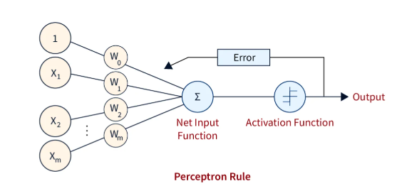

Neural Networks Multi Layer Perceptron:
The Perceptron defines the first step into Neural Networks:
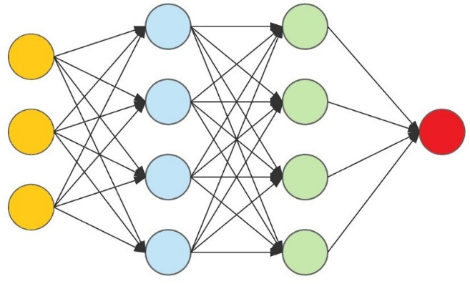

Perceptrons are often used as the building blocks for more complex neural networks, such as multi-layer perceptrons (MLPs) or deep neural networks (DNNs).
By combining multiple perceptrons in layers and connecting them in a network structure, these models can learn and represent complex patterns and relationships in data, enabling tasks such as image recognition, natural language processing, and decision making.
Backpropagation for Training an MLP:
Backpropagation is a supervised learning algorithm used to train Multi-Layer Perceptrons (MLPs) by adjusting weights to minimize the error. It works using Gradient Descent.
The following steps used in Backpropagation training.
Forward Propagation: Inputs pass through the MLP layer by layer. Each neuron applies weights, bias, and an activation function. The final output is compared with the actual label to compute the error.
Compute the Loss (Error): Use a loss function such as, Mean Squared Error (MSE) or Cross-Entropy to measure how far the predicted output is from the actual value.
Backward Propagation (Weight Update): Compute gradients of the loss function w.r.t each weight using the chain rule of differentiation. Propagate errors backward from the output layer to the input layer. Update weights using Gradient Descent (or its variations like Adam, RMSprop).

Repeat Until Convergence: Forward propagate → Compute Loss → Backpropagate → Update Weights. Repeat for multiple epochs until the loss is minimized.
Regression is a supervised machine learning technique which is used to predict continuous values based on the input.

Regression shows a line or curve that passes through all the data points on a target-predictor graph in such a way that the vertical distance between the data points and the regression line is minimum.”
Regression finds correlations between dependent and independent variables. Therefore, regression algorithms help predict continuous variables such as house prices, market trends, weather patterns, oil and gas prices (a critical task these days!), etc.
Regression models are of following two types −
Simple regression model − This is the most basic regression model in which predictions are formed from a single, univariate feature of the data.
Y= a + bX + e
Multiple regression model − As name implies, in this regression model the predictions are formed from multiple features of the data.

Linear regression can be expressed mathematically as:
Y= β₀+ β₁X+ ε
Here,
- Y= Dependent Variable
- X= Independent Variable
- β 0= intercept of the line
- β1 = Linear regression coefficient (slope of the line)
- ε = random error
The last parameter, random error ε, is required as the best fit line also doesn't include the data points perfectly.

It is mainly used for prediction, forecasting, time series modeling, and determining the causal-effect relationship between variables.

Important Terminologies Related to the Regression Analysis:
- Dependent Variable: The main factor in Regression analysis which we want to predict or understand is called the dependent variable. It is also called target variable.
- Independent Variable: The factors which affect the dependent variables or which are used to predict the values of the dependent variables are called independent variable, also called as a predictor.
- Outliers: Outlier is an observation which contains either very low value or very high value in comparison to other observed values. An outlier may hamper the result, so it should be avoided.
- Multicollinearity: If the independent variables are highly correlated with each other than other variables, then such condition is called Multicollinearity. It should not be present in the dataset, because it creates problem while ranking the most affecting variable.
- Underfitting and Overfitting: If our algorithm works well with the training dataset but not well with test dataset, then such problem is called Overfitting. And if our algorithm does not perform well even with training dataset, then such problem is called underfitting.
Below are some other reasons for using Regression analysis:
- Regression estimates the relationship between the target and the independent variable.
- It is used to find the trends in data.
- It helps to predict real/continuous values.

Types of Regression:
There are various types of regressions which are used in data science and machine learning.
1. Linear Regression 2. Logistic Regression 3. Polynomial Regression 4. Support Vector Regression 5. Decision Tree Regression 6. Random Forest Regression

Simple Linear Regression:
A simple straight-line equation involving slope (dy/dx) and intercept (an integer/continuous value) is utilized in simple Linear Regression.
Y= a+bX where Y denotes the output X is the independent variable, and a is the intercept when X=0. With this equation, the algorithm trains the model of machine learning and gives the most

accurate output. Simply b (scale factor to each input value)., a (Gives an additional degree of freedom) is called linear coefficients.

Multiple Linear Regression:
When a number of independent variables more than one, the governing linear equation applicable to regression takes a different form like:
Y= b0+ b1X1 + b2X2… bnXn where represents the coefficient responsible for impact of different independent variables X1, X2 etc. This machine learning algorithm, when applied, finds the values of coefficients b0, b1, b2, etc., and gives the best fitting line.
The difference between the actual and predicted values is the error, i.e., (y - yˆ)² = y^(Loss Function).The average summation of all loss function values is called the cost function.
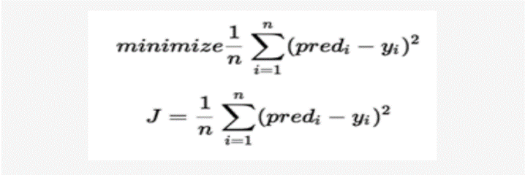

here J = cost function, n= number of observations ∑ = summation, pred_{i} = predicted output and yi = actual value.
The error difference is squared for each value and then the average of the sum of squares of error gives us the cost function. It is also referred to as Mean Square Error (MSE).
A slower learning rate takes an unusually long time and computationally proves expensive.
The faster learning rate may lead to an undesired position, making it difficult to come back on the correct track to reach the global minimum.
Hence the learning rate should be neither too slow nor too fast if the global minimum is to be reached efficiently.

Simple linear regression algorithm(using Ordinary Least Squares Method)
Simple linear regression formula: Y= ( a + b X )+e
where Y-target variable, X-Predictor, a-intercept , b-slope , e- error, which is the difference between predicted and actual values of Y, for least sum of square errors;
b= ∑ (Xi- Xmean) (Yi-Ymean)/ ∑ (Xi- Xmean) ²
a= Ymean - b Xmean
Step 1. Calculate the mean of X and Y
Step 2. Calculate the errors of X and Y
Step 3. Get the Product
Step 4. Get the summation of the products
Step 5. Square the difference of X
Step 6. Get the sum of Squarred difference
Step 7. Divide the output of step 4 by output of step 6 to calculate ‘b’
Step 8. Calculate the ‘a’ using the value of ‘b’
Step 9. Asses Model performance with test data
Step 10. Now the model is ready to find prediction of new data.

Logistic Regression:
- Logistic regression is another supervised learning algorithm which is used to solve the classification problems. In classification problems, we have dependent variables in a binary or discrete format such as 0 or 1.
- Logistic regression algorithm works with the categorical variable such as 0 or 1, Yes or No, True or False, Spam or not spam, etc.
- It is a predictive analysis algorithm which works on the concept of probability.
- Logistic regression is a type of regression, but it is different from the linear regression algorithm in the term how they are used.
- Logistic regression uses sigmoid function or logistic function which is a complex cost function. This sigmoid function is used to model the data in logistic regression. The function can be represented as:
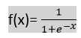
f(x)= Output between the 0 and 1 value.
x= input to the function
f(X) – probability of success the event =P
odd= P/1-P
ln(P/(1-P )) = a+bX
P/(1-P) = e ^{a+bX}
P=(1-P) e ^{a+bX}
P(1+ e ^{a+bX} ) ⁼ e ^{a+bX}
P= e ^{a+bX} / (1+ e ^{a+bX} )

When we provide the input values (data) to the function, it gives the S-curve as follows:

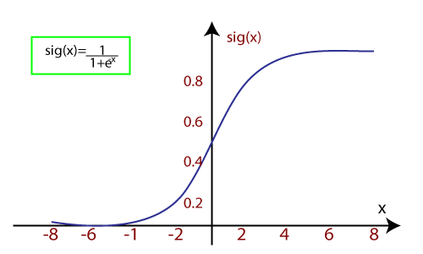
It uses the concept of threshold levels, values above the threshold level are rounded up to 1, and values below the threshold level are rounded up to 0.
There are three types of logistic regression:
- Binary(0/1, pass/fail)
- Multi(cats, dogs, lions)
- Ordinal(low, medium, high)
- Polynomial Regression is a type of regression which models the non-linear dataset using a linear model.
- It is similar to multiple linear regression, but it fits a non-linear curve between the value of x and corresponding conditional values of y.
Suppose there is a dataset which consists of datapoints which are present in a non-linear fashion, so for such case, linear regression will not best fit to those datapoints. To cover such datapoints, we need Polynomial regression.
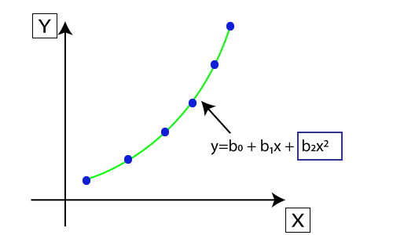
- The equation for polynomial regression also derived from linear regression equation that means Linear regression equation Y= b₀+ b₁x, is transformed into Polynomial regression equation Y= b₀+b₁x+ b₂x²+ b₃x³+.....+ b_{n}x^{n}.

- Here Y is the predicted/target output, b₀, b₁,... b_{n} are the regression coefficients. x is independent/input variable.
- The model is still linear as the coefficients are still linear with quadratic

Support Vector Machine:
Support Vector Machine is a supervised learning algorithm which can be used for regression as well as classification problems, first identified by Vladimir Vapnik and his colleagues in 1992. SVM regression is considered a nonparametric technique because it relies on kernel functions. So if we use it for regression problems, then it is termed as Support Vector Regression.
Support Vector Regression is a regression algorithm which works for continuous variables. Below are some keywords which are used in Support Vector Machine
Hyperplane: In general, SVM, it is a separation line between two classes, but in SVR, it is a line which helps to predict the continuous variables and cover most of the datapoints.
Boundary line: Boundary lines are the two lines apart from hyperplane, which creates a margin for datapoints.
Support vectors: Support vectors are the datapoints which are nearest to the hyperplane and opposite class.
Margin: The margin is the distance between the hyperplane and the closest data points from both classes. SVM aims to maximize this margin.
Kernel: It is a function used to map a lower-dimensional data into higher dimensional data.
In SVM, we always try to determine a hyperplane with a maximum margin, so that maximum number of datapoints are covered in that margin. The main goal of SVMis to consider the maximum datapoints within the boundary lines and the hyperplane (best-fit line) must contain a maximum number of datapoints. Consider the below image:
Applications: Image classification, text classification, bioinformatics identifying cancer disease and many other supervised learning tasks like.
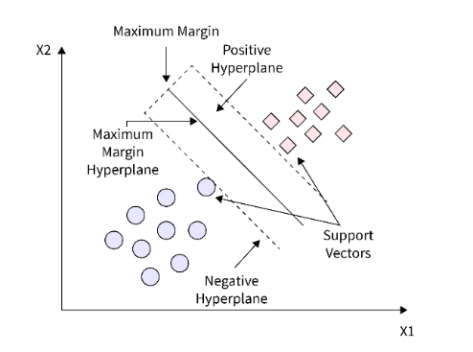

Linear SVM: When the data points are linearly separable into two classes, the data is called linearly-separable data. We use the linear SVM classifier to classify such data.
Non-linear SVM: When the data is not linearly separable, we use the non-linear SVM classifier to separate the data points.
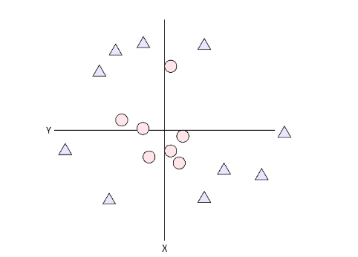

Kernel used to transform the Lower Dimension data points to Higher Dimension
We cannot separate the above data points with a single line. Also, if we give more than two classes, it is impossible to separate them with a single straight line. Consider the following example,
There are two classes of data points that a straight line cannot separate. But, a circular hyperplane can separate them, hence we can introduce a coordinate z, with the help of x and y, where z = x²+y². Now after introducing the third dimension, the graph changes to:-
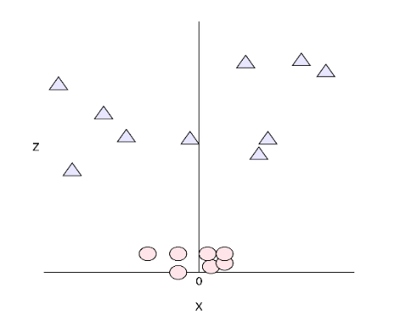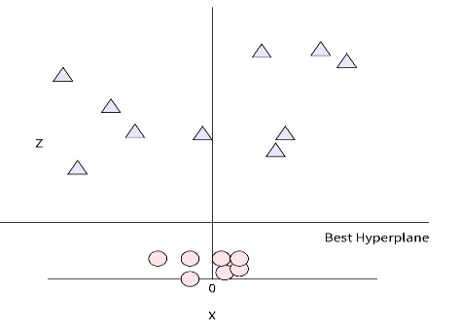

The above depiction of data points is linearly separable and can be separated by a straight-line hyperplane.
This representation is in 3-d with z-axis. In 2-D, the graph looks like this,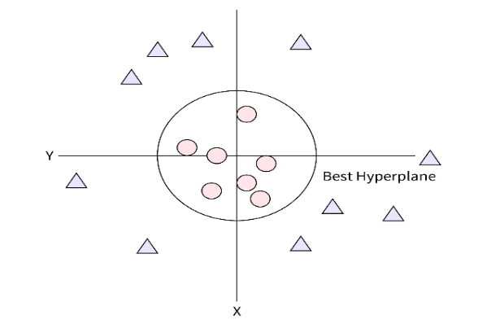

SVM: Support Vector Machines (SVM) is a powerful supervised learning algorithm used for classification and regression. It works by finding the optimal hyperplane that best separates different classes.
SVM finds the best hyperplane that maximizes the margin between two classes.
The support vectors are the data points closest to the hyperplane.
The decision boundary is given by:
w.x+b=0
Works well when data is linearly separable (i.e., can be separated by a straight line).
Linearly Non-Separable Case (Soft Margin SVM):
When data overlaps or has noise, we allow some misclassification.
Introduces slack variables (ξ) to allow some violations of the margin.
The optimization problem becomes:
min1/2||w||² + C∑ ξi

The C parameter controls the trade-off between maximizing the margin and minimizing misclassification.
Non-Linear SVM:
When data cannot be separated linearly, a straight line (or hyperplane) won’t work.
Instead of drawing a straight boundary, we map data to a higher-dimensional space where it becomes linearly separable. This is done using the Kernel Trick.
Kernel Trick (Key Idea in Non-Linear SVM):
The Kernel Trick transforms data into a higher dimension without explicitly computing it.
Some common kernels:
1. Linear Kernal -used to non-linear separable data
2. Polynomial Kernel: Captures polynomial relationships. K(x,y)=(x⋅y+c)^{d}
3. Gaussian (RBF) Kernel: Handles complex boundaries. K(x,y)=e^{−γ∣∣x−y∣∣2}
Instead of computing φ(x) explicitly, we just compute the dot product in the new space.
Polynomial Kernel: Captures polynomial relationships
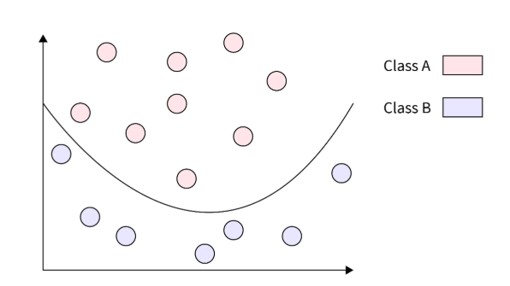
Fig. Non linear separable Case

UNIT-V: Clustering: Introduction to Clustering, Partitioning of Data, Matrix Factorization Clustering of Patterns, Divisive Clustering, Agglomerative Clustering, Partitional Clustering, K-Means Clustering, Soft Partitioning, Soft Clustering, Fuzzy C-Means Clustering, Rough Clustering, Rough K-Means Clustering Algorithm, Expectation Maximization-Based Clustering, Spectral Clustering.
Introduction to Clustering: Clustering refers to the process of arranging or organizing objects according to specific criteria. The task of grouping data points based on their similarity with each other is called Clustering or Cluster Analysis. This method is defined under the branch of unsupervised learning, which aims at gaining insights from unlabelled data points.
For Example, In the graph given below, we can clearly see that there are 3 circular clusters forming on the basis of distance.
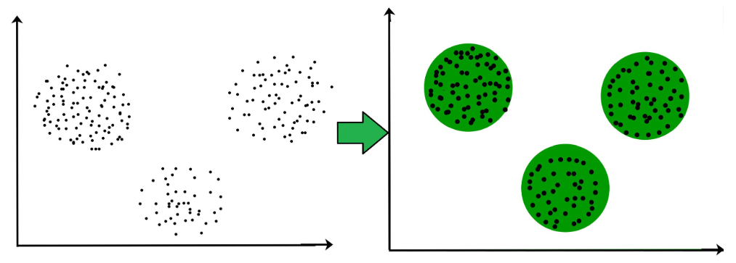

Broadly speaking, there are 2 types of clustering that can be performed to group similar data points:
Hard Clustering: In this type of clustering, each data point belongs to a cluster completely or not. For example, Let’s say there are 4 data point and we have to cluster them into 2 clusters. So each data point will either belong to cluster 1 or cluster 2.
Soft Clustering: In this type of clustering, instead of assigning each data point into a separate cluster, a probability or likelihood of that point being that cluster is evaluated. For example, Let’s say there are 4 data points and we have to cluster them into 2 clusters. So we will be evaluating a probability of a data point belonging to both clusters. This probability is calculated for all data points.

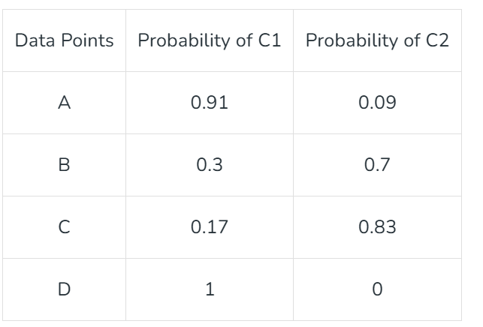

Uses of Clustering
Market Segmentation: Businesses use clustering to group their customers and use targeted advertisements to attract more audience.
Market Basket Analysis: Shop owners analyse their sales and figure out which items are majorly bought together by the customers.
Social Network Analysis: Social media sites use your data to understand your browsing behavior and provide you with targeted friend recommendations or content recommendations.
Medical Imaging: Doctors use Clustering to find out diseased areas in diagnostic images like X-rays.
Anomaly Detection: To find outliers in a stream of real-time dataset or forecasting fraudulent transactions we can use clustering to identify them.
Simplify working with large datasets: Each cluster is given a cluster ID after clustering is complete. Now, you may reduce a feature set’s whole feature set into its cluster ID
Types of Clustering Methods
Clustering is the process of determining how related the objects are based on a metric called the similarity measure. Similarity metrics are easier to locate in smaller sets of features and harder as the number of features increases.
Various types of clustering algorithms are:
- Centroid-based Clustering (Partitioning methods)
- Density-based Clustering (Model-based methods)
- Connectivity-based Clustering (Hierarchical clustering)

1. Centroid-based Clustering (Partitioning methods)
Centroid-based clustering organizes data points around central vectors (centroids) that represent clusters. Each data point belongs to the cluster with the nearest centroid. Generally, the similarity measure chosen for these algorithms are Euclidian distance, Manhattan Distance or Minkowski Distance.
It remains the most popular type of clustering due to its simplicity and efficiency. Popular algorithms of Centroid-based clustering are:
- K-means and
- K-medoids clustering

2. Density-based Clustering (Model-based methods)
Density-based clustering identifies clusters as areas of high density separated by regions of low density in the data space. Unlike centroid-based methods, density-based clustering automatically determines the number of clusters and is less susceptible to initialization positions.
Key Characteristics:
- Can find arbitrarily shaped clusters
- Handles noise and outliers well
- Excels with clusters of different sizes and shapes
- Ideal for datasets with irregularly shaped or overlapping clusters
- Effectively manages both dense and sparse data regions
- Focus on local density allows detection of various cluster morphologies
The most popular density-based clustering algorithm is DBSCAN and OPTICS (Ordering Points To Identify Clustering Structure).
3. Connectivity-based Clustering (Hierarchical clustering)
Connectivity-based clustering builds a hierarchy of clusters using a measure of connectivity based on distance when organizing a collection of items based on their similarities. This method builds a dendrogram, a tree-like structure that visually represents the relationships between objects.
At the base of the tree, each object starts as its own individual cluster. The algorithm then evaluates how similar the objects are to one another and begins merging the closest pairs of clusters into larger groups. This process continues iteratively, with clusters being combined step by step, until all objects are united into a single cluster at the top of the tree.

There are 2 approaches for Hierarchical clustering:
Divisive Clustering: It follows a top-down approach, here we consider all data points to be part one big cluster and then this cluster is divided into smaller groups.
Agglomerative Clustering: It follows a bottom-up approach, here we consider all data points to be part of individual clusters and then these clusters are clubbed together to make one big cluster with all data points.
Traditional “hard” clustering methods, where each data point is assigned to exactly one cluster. These methods, like K-Means and hierarchical clustering, are powerful and widely used, but they have limitations when dealing with ambiguous or overlapping data. After learning all about hard clustering methods we can addresses these limitations with soft clustering that allows data points to belong to multiple clusters simultaneously, with varying degrees of membership. This approach is particularly useful when the boundaries between clusters are not clear-cut or when data points exhibit characteristics of more than one group.
Two of the most popular soft clustering techniques are: Distribution-based Clustering and Fuzzy Clustering
4. Distribution-based Clustering
Distribution-based clustering is a technique that assumes data points are generated from a mixture of probability distributions (e.g., Gaussian, Poisson, etc.). The goal is to identify clusters by estimating the parameters of these distributions. In distribution-based clustering:
- Each cluster is represented by a probability distribution.
- Data points are assigned to clusters based on how likely they are to belong to each distribution.
- Unlike distance-based methods (e.g., K-Means), this approach can capture clusters of varying shapes, sizes, and densities.
Many real-world datasets, such as sensor data, financial data, or biological measurements, naturally follow statistical distributions. The most popular distribution-based clustering algorithm is Gaussian Mixture Model.

5. Fuzzy Clustering
Fuzzy clustering allows data points to belong to multiple clusters with varying degrees of membership.
- Each data point is assigned a membership value between 0 and 1 for every cluster.
- These membership values indicate the degree to which a data point belongs to a particular cluster.
Please refer to fuzzy clustering methods for in-depth understanding. Although this method and it’s algorithms are used for higher-level problem statements involving complex datasets.
Partitioning of data - Grouping of data in database application improves the data access.
Matrix factorization: Let there be n data points in an l-dimensional space. We can represent it as a matrix Xn× l. It is possible to approximate X as a product of two matrices B_{n× K} and C_{K× l}. So, X ≈ BC, where B is the cluster assignment matrix and C is the representatives matrix.
The Expectation-Maximization (EM) algorithm is an iterative method used in unsupervised machine learning to estimate unknown parameters in statistical models. It helps find the best values for unknown parameters, especially when some data is missing or hidden.
It works in two steps:
- E-step (Expectation Step): Estimates missing or hidden values using current parameter estimates.
- M-step (Maximization Step): Updates model parameters to maximize the likelihood based on the estimated values from the E-step.
This process repeats until the model reaches a stable solution, improving accuracy with each iteration. EM is widely used in clustering (e.g., Gaussian Mixture Models) and handling missing data.

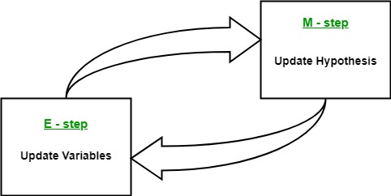
Expectation-Maximization in EM Algorithm
By iteratively repeating these steps, the EM algorithm seeks to maximize the likelihood of the observed data. It is commonly used for clustering, where latent variables are inferred and has applications in various fields, including machine learning, computer vision, and natural language processing.
- Latent Variables: These are hidden or unmeasured variables that affect what we can observe in the data. We can’t directly see them, but we can make educated guesses about them based on the data we can see.
- Likelihood: This refers to the probability of seeing the data we have, based on certain assumptions or parameters. The EM algorithm tries to find the best parameters that make the data most likely.
- Log-Likelihood: This is just the natural log of the likelihood function. It’s used to make calculations easier and measure how well the model fits the data. The EM algorithm tries to maximize the log-likelihood to improve the model fit.
- Maximum Likelihood Estimation (MLE): This is a technique for estimating the parameters of a model. It does this by finding the parameter values that make the observed data most likely (maximizing the likelihood).

- Posterior Probability: In Bayesian methods, this is the probability of the parameters, given both prior knowledge and the observed data. In EM, it helps estimate the “best” parameters when there’s uncertainty about the data.
- Expectation (E) Step: In this step, the algorithm estimates the missing or hidden information (latent variables) based on the observed data and current parameters. It calculates probabilities for the hidden values given what we can see.
- Maximization (M) Step: This step updates the parameters by finding the values that maximize the likelihood, based on the estimates from the E-step. It often involves running optimization methods to get the best parameters.
- Convergence: Convergence happens when the algorithm has reached a stable point. This is checked by seeing if the changes in the model’s parameters or the log-likelihood are small enough to stop the process.
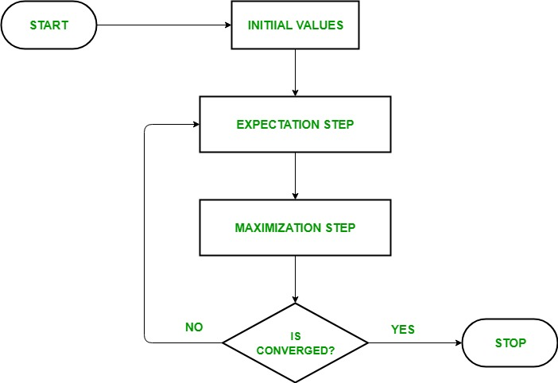
Fig. EM Algorithm Flow chart
Advantages of EM algorithm:
- Always improves results – With each step, the algorithm improves the likelihood (chances) of finding a good solution.
- Simple to implement – The two steps (E-step and M-step) are often easy to code for many problems.
- Quick math solutions – In many cases, the M-step has a direct mathematical solution (closed-form), making it efficient

Disadvantages of EM algorithm
- Takes time to finish – It converges slowly, meaning it may take many iterations to reach the best solution.
- Gets stuck in local best – Instead of finding the absolute best solution, it might settle for a “good enough” one.
- Needs extra probabilities – Unlike some optimization methods that only need forward probability, EM requires both forward and backward probabilities, making it slightly more complex.
Spectral Clustering:
Spectral Clustering is a variant of the clustering algorithm that uses the connectivity between the data points to form the clustering. It uses eigenvalues and eigenvectors of the data matrix to forecast the data into lower dimensions space to cluster the data points. It is based on the idea of a graph representation of data where the data point are represented as nodes and the similarity between the data points are represented by an edge.
Steps performed for spectral Clustering
Building the Similarity Graph Of The Data: This step builds the Similarity Graph in the form of an adjacency matrix which is represented by A. The adjacency matrix can be built in the following manners:
Epsilon-neighbourhood Graph: A parameter epsilon is fixed beforehand. Then, each point is connected to all the points which lie in its epsilon-radius. If all the distances between any two points are similar in scale then typically the weights of the edges ie the distance between the two points are not stored since they do not provide any additional information. Thus, in this case, the graph built is an undirected and unweighted graph.
K-Nearest Neighbours A parameter k is fixed beforehand. Then, for two vertices u and v, an edge is directed from u to v only if v is among the k-nearest neighbours of u. Note that this leads to the formation of a weighted and directed graph because it is not always the case that for each u having v as one of the k-nearest neighbours, it will be the same case for v having u among its k-nearest neighbours. To make this graph undirected, one of the following approaches is followed:-

1. Direct an edge from u to v and from v to u if either v is among the k-nearest neighbours of u OR u is among the k-nearest neighbours of v.
2. Direct an edge from u to v and from v to u if v is among the k-nearest neighbours of u AND u is among the k-nearest neighbours of v.
3. Fully-Connected Graph: To build this graph, each point is connected with an undirected edge-weighted by the distance between the two points to every other point. Since this approach is used to model the local neighbourhood relationships thus typically the Gaussian similarity metric is used to calculate the distance.
4. Projecting the data onto a lower Dimensional Space: This step is done to account for the possibility that members of the same cluster may be far away in the given dimensional space. Thus the dimensional space is reduced so that those points are closer in the reduced dimensional space and thus can be clustered together by a traditional clustering algorithm. It is done by computing the Graph Laplacian Matrix.
Spectral Clustering is a type of clustering algorithm in machine learning that uses eigenvectors of a similarity matrix to divide a set of data points into clusters. The basic idea behind spectral clustering is to use the eigenvectors of the Laplacian matrix of a graph to represent the data points and find clusters by applying k-means or another clustering algorithm to the eigenvectors.
Advantages of Spectral Clustering:
- Scalability: Spectral clustering can handle large datasets and high-dimensional data, as it reduces the dimensionality of the data before clustering.
- Flexibility: Spectral clustering can be applied to non-linearly separable data, as it does not rely on traditional distance-based clustering methods.
- Robustness: Spectral clustering can be more robust to noise and outliers in the data, as it considers the global structure of the data, rather than just local distances between data points.
Disadvantages of Spectral Clustering:
- Complexity: Spectral clustering can be computationally expensive, especially for large datasets, as it requires the calculation of eigenvectors and eigenvalues.

- Model selection: Choosing the right number of clusters and the right similarity matrix can be challenging and may require expert knowledge or trial and error.
Rough Clustering in Machine Learning:
Rough clustering is a clustering technique that uses rough set theory to handle uncertainty and overlapping clusters. Unlike traditional clustering methods (e.g., k-means, hierarchical clustering), where each data point belongs strictly to one cluster, rough clustering allows soft boundaries—meaning a data point can partially belong to multiple clusters.
- Lower Approximation: The set of data points that definitely belong to a cluster.
- Upper Approximation: The set of data points that possibly belong to a cluster.
- Boundary Region: The difference between the upper and lower approximations, containing elements that could belong to multiple clusters.
Advantages of Rough Clustering
- Handles uncertain and noisy data better.
- Provides flexibility in overlapping clusters.
- More realistic in real-world scenarios where strict clustering is not always possible.
Applications
- Medical Diagnosis: Grouping patients with overlapping symptoms.
- Image Segmentation: Handling fuzzy boundaries between objects.
- Customer Segmentation: When users show mixed behaviour patterns.
Hard Clustering vs. Rough Clustering in Machine Learning
No, hard clustering and rough clustering are different in machine learning. The key difference lies in how they handle uncertainty and cluster membership.

1. Hard Clustering
- Each data point belongs to exactly one cluster.
- There is no overlap between clusters.
- Example: K-Means Clustering, where every point is assigned to the nearest centroid.
Example
Imagine classifying students into "Pass" and "Fail" groups based on marks. In hard clustering, each student is either in the "Pass" or "Fail" group—there’s no in-between.
2. Rough Clustering
Data points can belong to multiple clusters with different degrees of membership. Uses lower approximation (certain) and upper approximation (possible) for clustering. Example: Rough K-Means, where a data point can partially belong to multiple clusters.
Example
In medical diagnosis, a patient may show symptoms that fit multiple diseases. Instead of strictly classifying them into one category, rough clustering allows them to be in the boundary region of multiple diagnoses.
Key Differences
Feature | Hard Clustering | Rough Clustering
Membership | Strict (one cluster) | Overlapping clusters
Handling Uncertainty poor |  |  | Better
Boundary Region No |  |  | Yes (lower & upper approx.)

Soft clustering and rough clustering are different in machine learning. While both methods allow data points to belong to multiple clusters, they differ in how they define and handle uncertainty and membership.
So, rough clustering is a more flexible approach compared to hard clustering, especially when data is uncertain or has overlapping categories.

